MECHANICS I

Remember to photocopy 4 pages onto one sheet by going A3→A4 AND back to back on the photocopier

Student name: ________________________________

This booklet contains every higher and ordinary level question that has appeared on an exam paper on this topic from 2002–2023
Worked solutions to Ordinary Level Maths questions can be found at the end of the booklet.
Fully worked solutions to all higher level past papers can be found on the homepage of thephysicsteacher.ie

Screencasts of all topics plus a wide range of other resources via this link

You can find this document plus all other booklets on the homepage of thephysicsteacher.ie
Last updated: 04/08/2024
Noel Cunningham

Contents
The science of learning quiz: Part 5 3
1: SPEED, DISPLACEMENT AND VELOCITY 5
Displacement 6
Average speed 7
Instantaneous speed 8
MEASUREMENT OF AVERAGE SPEED USING A TICKER TAPE TIMER 9
Velocity 11
Distance–time graphs 11
The science of learning quiz: Part 6 12
2: ACCELERATION 14
Equations of motion 15
Velocity – time graphs 17
MEASUREMENT OF ACCELERATION USING A TICKER-TAPE-TIMER 21
MEASUREMENT OF ACCELERATION USING TWO LIGHT GATES 25
Acceleration due to gravity: ‘g’ 26
Deriving the three equations of motion 28
MEASUREMENT OF ACCELERATION DUE TO GRAVITY (g) 30
The science of learning quiz: Part 7 35
3: FORCE 37
Relationship between force, mass and acceleration 38
TO SHOW THAT ACCELERATION IS PROPORTIONAL TO THE FORCE CAUSING IT 39
Momentum 47
TO VERIFY THE PRINCIPLE OF CONSERVATION OF MOMENTUM 50
Newton’s laws of motion 54
To Show that F = ma is a special case of Newton’s second law 60
Impulse 61
Newton’s laws of motion and the physics of concussions 63
Relationship between mass and weight 64
SLOP 68
Comment exam mistakes 69
The science of learning quiz: Part 8 70
MECHANICS I EXAM QUESTIONS 2002 – 2022 Ordinary and Higher level 72
Velocity and acceleration 72
Velocity and acceleration 74
Forces: Ordinary level 75
Forces: Higher level 76
Momentum: Ordinary level 77
Momentum: Higher level 78
SOLUTIONS TO ORDINARY LEVEL EXAM QUESTIONS 2002 – 2023 79

If the misery of the poor be caused not by the laws of nature, but by our institutions, great is our sin.
Charles Darwin, Voyage of the Beagle

Aristotle said a bunch of stuff that was wrong. Galileo and Newton fixed things up. Then Einstein broke everything again. Now, we’ve basically got it all worked out, except for small stuff, big stuff, hot stuff, cold stuff, fast stuff, heavy stuff, dark stuff, turbulence and the concept of time.

Science: Abridged Beyond the Point of Usefulness, Zach Weinersmith
And bright stuff. He forgot to mention bright stuff. The science of light is one of the greatest mysteries in all of science.

We are bathing in mystery and confusion… That will always be our destiny. The universe will always be much richer than our ability to understand it.
Carl Sagan

The science of learning quiz: Part 5

- You may be able to multitask – but your brain certainly can’t. Explain.

- So you’re in Maths class working through problems, or English class working on an essay, or in a study period working on your homework. All this time you’re chatting away to your friend but it’s okay because you’re getting the work done - right? What’s wrong with this picture? Care to guess what percentage of your class time is spent like this over the school day?

- Habit eats strategy for breakfast. What is the significance of this phrase for students?

- Three frogs are sitting on a log. One decides to jump off. How many remain?

Answers

- You may be able to multitask – but your brain certainly can’t. Explain.
We all know it’s possible to paint the walls of your room while listening to the radio or talking on the phone. So yes you can multitask – go you. Your brain on the other hand can only focus on one thing at a time. You can drive and text, but you’re not actually doing both at the same time – you’re just switching from one to the other quickly. And if you’re lucky you’ll be able to switch concentration so rapidly that you won’t kill yourself – or anybody else. But if you’re trying to learn then anything other than what you’re trying to focus on is a distraction.
A quick way to see if you’re engaging with the material is to ask yourself, “is it possible to study in this way while checking Facebook, holding a conversation or watching The Simpsons?”
If the answer is ‘yes’ then there is no effective learning taking place. Your brain simply cannot be engaged in two things at once. And therefore there is no significant encoding taking place.
Sorry
Why the Human Brain Can't Multitask: 2 min YouTube video from Fora TV
Can You Really Multitask? 4 min video from SciShow

- All this time you’re chatting away to your friend but it’s okay because you’re getting the work done - right? What’s wrong with this picture?
Hopefully you can use the information garnered from the previous answer to see that chatting while working is just another example of two activities that seem to be totally innocuous (innocent) but unfortunately are not. The act of chatting means that the brain is no longer able to engage with (or think about) the material to the extent that is required for it to be securely stored in long term memory.

This is possibly the greatest failing in my own teaching (although it is a long list); I generally allow students to chat once they’re “getting the work done” in class. I like the idea of the atmosphere in class being quite easy-going but in reality I know that I am letting my students down. In fairness to me I do point this out to my students quite regularly, only to be told that they’re not really ‘chatting’; they are discussing the physics problems. And of course a student has never been known to tell a lie . . .

- Habit eats strategy for breakfast. What is the significance of this phrase for students?
Having a study strategy or study plan is wonderful in theory but if you can’t change your poor study habits or tendency to prognosticate then it’s not likely to be much use, is it? The same goes for any good intentions; diet, exercise etc.

- Three frogs are sitting on a log. One decides to jump off. How many remain?
Three. Deciding isn’t the same as doing.

Back to the physics . . .

1: SPEED, DISPLACEMENT AND VELOCITY

Something to think about

- Two friends are playing with a ball on board a ship moving at a steady speed. One is standing near the front and the other near the back. Which one of them finds it easier to throw the ball to the other? (Ignore wave and wind effects).

- Imagine you are travelling in a car. You have a glass bottle in your hand. In which direction should you throw it to minimise the danger of it breaking on hitting the ground?

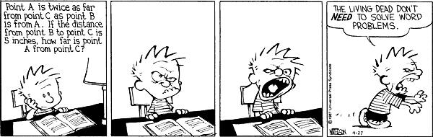

A mirror was left on the Moon by NASA Astronauts. It reflects lasers shone from Earth & tells us how far the Moon is. How can we use this to work out the distance between the Earth and the moon?
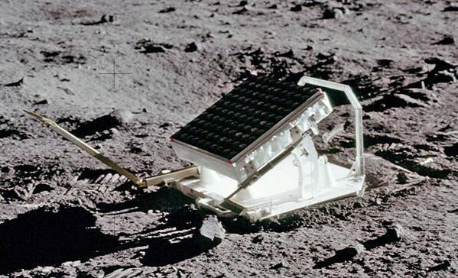

See the clip about this on The Big Bang comedy series (search “Mirror on the moon” on YouTube).

If 666 is the most evil number in the world, then 25.8069 is the root of all evil.

Student Notes

Displacement
Displacement is a straight-line distance in a given direction
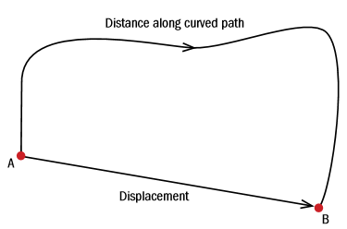
This can be a little tricky to grasp; another way to put this is to say that displacement is the straight-line distance between the two points.
If you travel half-way around a circular race-track of radius 100 m, your distance travelled will be half the circumference of the circle (2πr/2) which is this case would be 100π m (or 314 m), but your displacement would be the straight line distance, in this case the diameter of the circle: 200 m.

When giving displacement we should also include both the number representing the distance (known as the ‘magnitude’) and the direction between start and finish point.

Exam Question [2003]  A cyclist travels from A to B along the arc of a circle of radius 25 m as shown.  - Calculate the distance travelled by the cyclist.  - Calculate the displacement undergone by the cyclist. | - The displacement is equivalent to one quarter of the circumference of a circle  = $\frac{2πr}{4}= \frac{2π(25)}{4}$  = 12.5π = 39.3 m.  - The displacement is the straight line distance between A and B. We can find this suing sing Pythagoras’ theorem:  x² = 25² + 25²  ⇒ x = 35.3 m.  Direction is NW

The second is S.I. the unit of time.

The metre is the S.I. unit of distance and displacement.

The symbol for displacement is ‘s’.

Average speed

Speed is distance divided by time.

Or if you want to sound cleverer: Speed is the rate of change of distance with respect to time.

The unit of speed is the metre per second (m s⁻¹ or m/s).
$$average speed= \frac{total distance}{total time}$$

Every night I announce to my family that I’m going jogging tomorrow morning, but then I don’t go.
It’s a running joke.

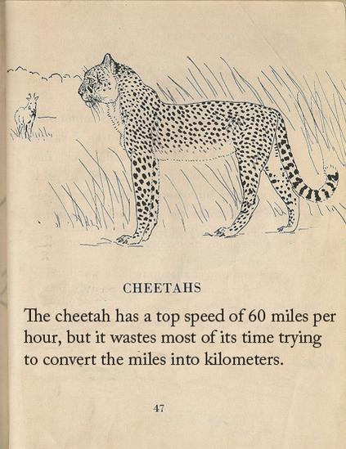


Instantaneous speed

It is important that you understand the difference between average speed and instantaneous speed.
When your speedometer indicates that you are doing 100 km hr⁻¹, it’s telling you that your instantaneous speed is 100 km hr⁻¹, not (obviously) your average speed for a full journey. Or think of a car that accelerates from rest and slams into a wall at 100 km hr⁻¹. 100 km hr⁻¹ definitely doesn’t represent the average speed in this case, just the final (instantaneous) speed.
To calculate instantaneous speed, you need to take a ‘very’ short time and divide the distance travelled by this time.

We come across this concept again in the next chapter. (Have you noticed that we use that phrase a lot?)

2020 Question 12 (a) [Ordinary Level]  A bus travels 30 km in 28 minutes at a constant speed.  - Convert 30 km into metres.  - Convert 28 minutes into seconds.  Use your answers to (i) and (ii) to calculate the speed of the bus in m s^{–1}. | Solution  - Convert 30 km into metres.  30000 m  - Convert 28 minutes into seconds.  28 × 60 = 1680 s  - Calculate the speed of the bus in m s^{–1}.  $speed=\frac{distance}{time}=\frac{30000}{1680}$ = 17.86 m s⁻¹
2012 Question 5 [Higher level]  The European aerospace group EADS is developing a hypersonic jet aircraft that will fly at four times the speed of sound, 330 m s⁻¹.  Express the speed of the aircraft in kilometres per hour. | Solution  First convert m to km and then convert seconds to hours.  Before we do that we first need to calculate the actual speed of the aircraft: 4 × 330 = 1320 m s⁻¹  Now to convert from m to km divide by 1000: 1320 m s⁻¹ = 1.320 km s⁻¹  To convert from kilometres per second to kilometres per hour multiply by (60)(60) or 3600:  1.320×3600 = 4752 km h^{–1}
2019 Question 5  A light‐year is the distance travelled by light in a vacuum in one year.  Calculate this distance in metres.  Note: speed of light = 3 × 10⁸ m s⁻¹ | Solution

MEASUREMENT OF AVERAGE SPEED USING A TICKER TAPE TIMER

APPARATUS: Ticker timer and tape, low-voltage a.c. power supply, trolley, runway.

DIAGRAM

PROCEDURE
- Set up the apparatus as in the diagram.
- Connect the ticker timer to a low-voltage power supply.
- Give the trolley a small push to start it moving.
- Adjust the angle of inclination of the runway until the trolley moves with constant speed, i.e. the spots on the tape are all equidistant.
- The ticker timer makes 50 dots per second.
Therefore the time interval between two adjacent spots is 0.02 s.
- Measure the length s of ten adjacent spaces. The time t is 10 × 0.02 = 0.2 s.
- Calculate speed using the formula $speed=\frac{distance}{time}$

- Repeat using pushes of varying strengths.
- Tabulate results as shown.
 | s (m) | t (s) | v (m s⁻¹)
Run #1
Run #1
Run #1

RESULTS:

CONCLUSION
The dots were evenly spaced throughout, illustrating that the velocity remained constant.

SOURCES OF ERROR / PRECAUTIONS
- Dust the runway to reduce friction.
- Raise the trolley to offset friction such that the trolley moves at constant velocity.
- Ignore the initial five or six dots on the tape as this shows the initial acceleration due to the push.

NOTE
- Tape one of your ticker-tape runs here and include any relevant calculations on the back or underneath:

Related exam questions

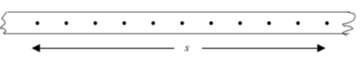
- The following represents the pattern of a section of ticker tape attached to a trolley travelling at constant speed.

- How many dots should we use when calculating the speed?
- For ten spaces we need eleven dots. What would be the effect (if any) of using five spaces instead of ten?
- Why don't we just use 2 dots to calculate the speed?
- What would be the effect of using twenty spaces?
- What would be the effect on the pattern if the trolley was moving faster?
- What would be the effect on the pattern if the trolley was moving more slowly?
- What would be the effect on the pattern if the trolley was stationary?
- What would be the effect on the pattern if the trolley was accelerating?
- What would be the effect on the pattern if the trolley was decelerating?
- Calculate the speed at which the trolley was moving.

The following represents the pattern of a section of ticker tape attached to a trolley travelling at constant speed. Calculate the speed at which the trolley was moving.
. . . . . . . . .

- [2004 OL]
Describe an experiment to measure the velocity of a moving object.

Solution
We set up as shown, turned on the ticker tape timer and released the trolley.
- We measured the distance between 11 dots on the tape.
- The time taken to cover that distance corresponded to the time for 10 intervals, where each interval was 1/50th of a second.

- We calculated velocity using the formula velocity = distance/time.

Velocity

Velocity is the rate of change of displacement with respect to time

The unit of velocity is the metre per second (m s⁻¹, or m/s).

Similar to distance and displacement, the difference between speed and velocity is that speed is just a number (‘magnitude’) whereas velocity incorporates both magnitude and direction. A short way of expressing this is to say that velocity is ‘speed in a given direction’.

$$velocity= \frac{displacement}{time}$$


So if you run along a circular path which is 600 m long and you finish back where you started in 100 seconds your average speed will be 600/100 = 6 m s⁻¹, but your average velocity will be zero (because the displacement is zero).
WTF?

Distance–time graphs

If you plot a graph of distance (on the y-axis) against time (on the x-axis), the slope of the graph will correspond to the speed of the object.
slope =

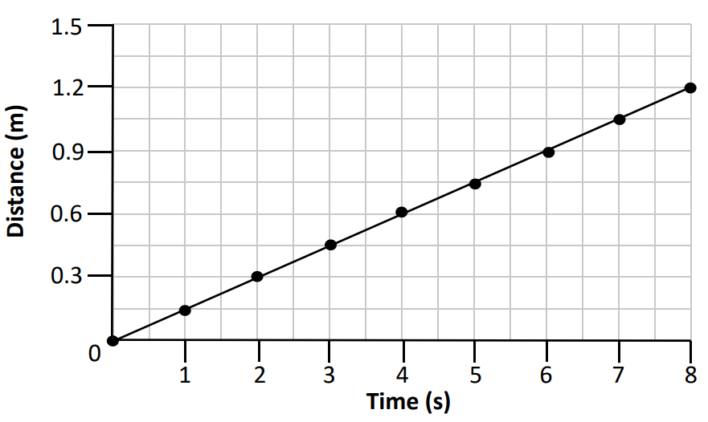
Exam question
A trolley moves along a horizontal track. The distance of the trolley from its starting point was measured every second for 8 seconds. The results are shown in the graph.

Calculate the average speed of the trolley. Include the unit for your answer.

Solution
Two points: (0,0) and (8, 1.2)

$Slope=\frac{y_{2}-y_{1}}{x_{2}-x_{1}}$ = $\frac{1.2-0}{8-0}$ = 0.15
Speed = 0.15 m s⁻¹

The science of learning quiz: Part 6

- “I've come to the conclusion Sweller's Cognitive Load Theory is the single most important thing for teachers to know.” Renowned educationalist Dylan Wiliam
What is Cognitive Load Theory?

- What is meant by the term ‘desirable difficulties’ and what is the significance of this term in relation to study skills?

- ‘Dual Coding’ is an excellent study technique, but one which is not well known. What is Dual Coding and why is it so effective?

Answers

- What is Cognitive Load Theory?
Before we answer directly we need to remind ourselves that our memory can be divided into long-term memory and short-term (working) memory. Learning occurs when we transfer information from short-term to long-term memory. But we can only hold a limited amount of information in short-term memory at any one time and if we’re very busy focusing on that then we have little chance of transferring information to long term memory. Imagine somebody expecting you to remember 3 random numbers (428, 592,128) and then asking you to divide each by 3 in your head without writing anything down. Asking you to learn something and do something at the same time means that you’re unlikely to do either of them successfully.
Cognitive Load Theory says that because short-term memory is limited, learning experiences should be designed to reduce working memory ‘load’ in order to promote schema acquisition.
Asking you to remember the first ten concepts above and critically analyse the first three would be an example of cognitive overload.
Link

- What is meant by the term ‘desirable difficulties’ and what is the significance of this term in relation to study skills?
Introducing certain difficulties into the learning process greatly improves long-term retention of the learned material.
This seems counter-intuitive. After all, the job of a teacher is to make the learning as easy as possible – right?
Wrong. It turns out that if the learning or memorising is very easy it can boost short term retention but because there is no real engagement the long term retention will be minimal.
That’s why we lean on something like highlighting as a study tool: It feels way better than flash cards. And you have something tangible to show for your time. Trying to recall something from memory requires mental strain which feels unpleasant, while just reading or highlighting is easy and can actually feel rather therapeutic.
Using Desirable Difficulties to Enhance Learning, Dr. Robert Bjork. YouTube 4 minutes

- ‘Dual Coding’ is an excellent study technique, but one which is not well known. What is Dual Coding and why is it so effective?
Our brains store visual information in a different area of the brain to audio or verbal information. So if we use both techniques when we first engage in note-taking it likely to lead to more success than would be the case if we just used one on its own. Note however that dual coding does not mean having complicated pictures and text with lots going on; it needs to be kept simple to avoid cognitive overload (having too much going on in your brain at the same time). Dual Coding performed correctly should reduce cognitive load rather than add to it.

Imagine learning about mitochondria. Just saying the word out loud will build confidence in using the word later on. A quick sketch will then help your brain to process it at least as effectively, if not more so, than just reading about it. Now make it more elaborate by showing how it’s connected to other areas in your course. I don’t know anything more about mitochondria so can’t help you with examples. I’m actually sorry I picked that word now.

2: ACCELERATION

Student Notes

Time | Velocity
1 second | 10 m/s
2 seconds | 20 m/s
3 seconds | 30 m/s
4 seconds | 40 m/s
Consider an object which is falling through the air.
Its instantaneous velocity after one, two, three and four seconds is given in the table on the right.

We can see that with every second that passes the velocity increases by 10 m/s.
Alternative ways of expressing this:
The velocity increases by 10 m/s per second or 10 m/s/s or 10 m/s² or 10 m s⁻².
Or we could just say that the acceleration is 10 m s⁻² (“ten metres per second squared”).

It would be a bit of a coincidence if the acceleration was exactly 10 m s⁻². In reality if a ball is falling through the air its acceleration will be approximately 9.8 m s⁻² (assuming no air-resistance).

The unit of acceleration is therefore the metre per second squared (m s⁻² or m/s²).
Acceleration is the rate of change of velocity with respect to time

$$acceleration= \frac{change in velocity}{time taken}$$



Equations of motion*

When an object (with initial velocity u) moves in a straight line with constant acceleration a, its displacement s from its starting point, and its final velocity v, change with time t.
Note that both v and u are instantaneous velocities.

The following equations tell us how five these quantities are related:

v = u + at

s = ut + ½ at²

v² = u² + 2as

u = initial velocity
v = final velocity
a = acceleration
s = displacement
t = time

Another useful equation is $s=\frac{(u+v)}{2}t$

Procedure for solving problems using equations of motion - UVAST

- Write down u, v, a, s and t underneath each other on the left hand side of the page, filling in the quantities you know, and put a question mark beside the quantity you are looking for.
- Write down the three equations of motion for each question until you know them off by heart.
- Decide which of the three equations has only one unknown in it.
- Substitute the known values in to this equation and solve to find the unknown.

- 3 is the magic number. Once you know 3 pieces of information you can work out everything else – you just have to pick the right equation.

- Directions are important – if any one variable is opposite in direction to the others then it must be assigned a negative value (assuming that the others are positive).


Exam questions – worked solutions

2005 Question 5 [Ordinary level]
A car accelerates from 10 m s⁻¹ to 30 m s⁻¹ in 5 seconds. What is its acceleration?
u = 10 m s⁻¹  v = 30 m s⁻¹  a = ?  s =  t = 5 s | v = u + at ⇒ a = ( v – u ) ÷ t  ⇒ a = (30 – 10) ÷ 5  ⇒ a = 4 m s⁻².
2021 Question 5 [Ordinary level]
A motorcar starts from rest and has an acceleration of 6 m s^{–2}.
Calculate the distance it travels in 12 s.
u = 0  v =  a = 6 m s⁻²  s =  t = 12 s | $$s=ut+\frac{1}{2}at^{2}$$  $s=0+\frac{1}{2}\left(6\right)({12}^{2})$  s = 432 m
2003 Question 5 [Ordinary level]
What is the shortest stopping time for a car which is travelling at 16 m s⁻¹ and has a maximum deceleration of 2.5 m s⁻²?
u = 16 m s⁻¹  v = 0  a = - 2.5 m s⁻²  s =  t = ? | v = u + at. 0 = 16 – 2.5t  t = 6.4 secs
2018 Question 12 (a) [Ordinary Level]
A train left a station from rest and accelerated at 0.4 m s⁻² to reach its top speed of 55 m s⁻¹.
Calculate how long it took the train to reach its top speed.
u = 0  v = 55 m s⁻¹  a = 0.4 m s⁻²  s =  t = ? | u = 0  v = 55 m s⁻¹  a = 0.4 m s⁻²  s =  t = ?

Using equations of motion to prove that 1= 2

Velocity – time graphs

2016 Question 5 [Higher level]
A sprinter starts from rest and accelerates uniformly for 3 secs until she reaches a velocity of 10 m s^{–1}.
She then runs at a constant velocity for 6 seconds before decelerating.
Sketch a velocity-time graph of her motion.
Notice that the question doesn’t say that the sprinter decelerates ‘to rest’ so we can’t assume that she does stop.  Therefore we can’t bring the final line all the way down. | 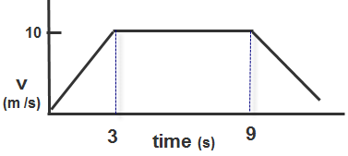

2014 Question 12 (a) [Ordinary Level]
A bus leaves a bus stop and accelerates from rest at 0.5 m s⁻² to reach a speed of 15 m s⁻¹.
It then maintains this speed for 100 seconds. When it approaches the next stop, the driver applies the brakes uniformly to bring the bus to a stop in 20 seconds.
- Calculate the time it took the bus to reach its top speed.
- Calculate the distance it travelled while at its top speed.
- Calculate the acceleration required to bring the bus to a stop.
- Sketch a velocity-time graph of the bus journey.

Notice that for each stage the values for v,u,a,s,t will be different so we need to write a new list for each stage.

Part (i)  u = 0  v = 15 m s⁻¹  a = 0.5 m s⁻²  s =  t = ? | v = u + at  15 = 0 + 0.5t  t = (15 ) / 0.5 = 30 s
Part (ii)  u = 15 m s⁻¹  v = 15 m s⁻¹  a = 0  s =  t = 100 s | s = ut + ½ at²  s = (15)(100) + ½ (0)(100)² = 1500 m
Part (iii)  u = 15 m s⁻¹  v = 0  a = ?  s =  t = 20 s | v = u + at  0 = 15 + a(20) -15 = a(20)  a= (-15 ) / 20 = – 0.75 m s ^{–2}
Part (iv)  see graph | 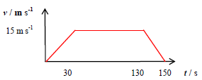

The area under the graph corresponds to the distance travelled.

If a graph is drawn of velocity (vertical-axis) against time (horizontal-axis) then the area under the graph corresponds to the distance travelled.

Calculate the total distance travelled based on the information in the graph.  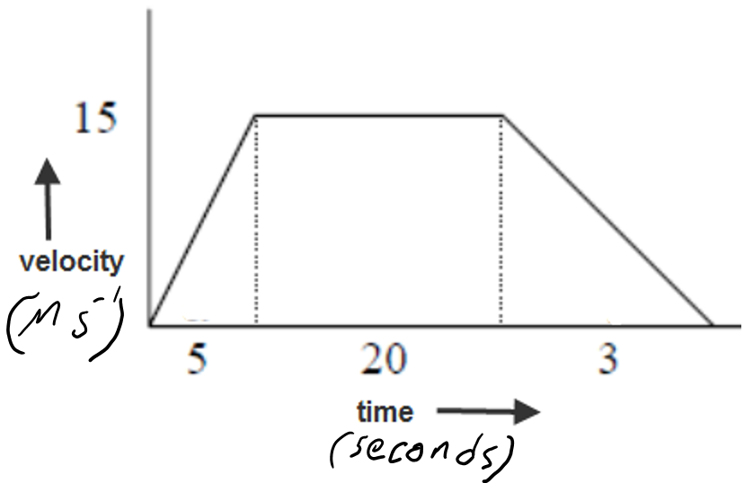 | We need to break the area under the graph into three separate sections and then find the area of each.  The area of the first section is a triangle so the area = (½)(5)(15) = 37.5 m  The area of the second section is a rectangle so the area = (20)(15) = 300 m  The area of the third section is a triangle so the area = (½)(3)(15) = 22.5 m  Total area = 37.5 + 300 + 22.5 = 360 m

Notes
- You could also use the equation s = ut + ½ at² for each section (but the method above takes less time).

- Velocity needs to be in m s⁻¹ and time needs to be in seconds. If time is in minutes or hours then you first need to convert to seconds.

- $Average speed= \frac{total distance}{total time}$

Two requirements to be a maths person:
1. Be a person
2. Do some maths.

Worked example
2008 Question 12 (a) [Ordinary Level]
A speedboat starts from rest and reaches a velocity of 20 m s⁻¹ in 10 seconds.
It continues at this velocity for a further 5 seconds.
The speedboat then comes to a stop in the next 4 seconds.
- Draw a velocity-time graph to show the variation of velocity of the boat during its journey.
- Use your graph to estimate the velocity of the speedboat after 6 seconds.
- Calculate the acceleration of the boat during the first 10 seconds.
- What was the distance travelled by the boat when it was moving at a constant velocity?

Part (i)
See graph

Part (ii) | See dotted lines on the graph:  v = 12 m s⁻¹.
Part (iii)  u = 0  v = 20 m s⁻¹  a =  s =  t = 10 s | v = u + at  20 = 0 + a(10)  a = 2 m s⁻²
Part (iv) | Distance travelled by the boat when it was moving at a constant velocity = area under this section of the graph.  Height = 20, base = 5  Area = 20×5 = 100 m

Graphing challenge
The graph below represents the speed-time graph for a particular sport. Which sport from the following list is it likely to be?
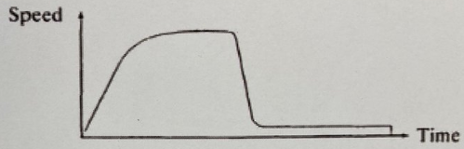
Fishing, pole vaulting, 100 meter sprint, sky diving, golf, archery, javelin throwing, high jumping, high diving, snooker, drag racing, water skiing

2010 Question 12 (a) [Higher Level]

The graph in Figure 2 represents the motion of a cyclist on a journey.
Using the graph, calculate the distance travelled by the cyclist and the average speed for the journey.

Solution
The Y-axis (speed) is km h⁻¹ we need to make convert from km h⁻¹ to m s⁻¹ on the Y-axis.
The X-axis (time) is in minutes so we need to convert from minutes to seconds on the X-axis.

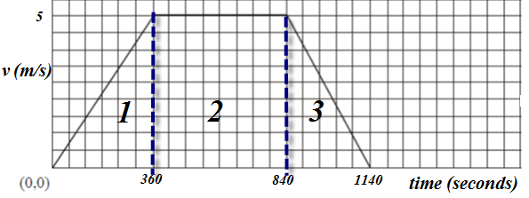
Y-axis
18 km h⁻¹ = $\frac{18000}{(60)(60)}$ = 5 m s⁻¹

X-axis
6 min = 360 secs
14 mins = 840 secs
19 min = 1140 secs

We can now use the fact that the area under the graph corresponds to the distance travelled:
Section 1 = half the base multiplied by the height = ½ (360) (5) = 900 m
Section 2 = base multiplied by the height = 480(5) = 2400 m
Section 3 = half the base multiplied by the height = ½ (300)(5) = 750 m
Total distance = 900 + 2400 + 750 = 4050 m

Total distance = 4050 m

$Average speed= \frac{total distance }{total time}$ = $\frac{4050}{1140 }$ = 3.55 m s⁻¹

Note that there are alternative (and shorter) ways of doing this which could have avoided changing the units to m s⁻¹ and s but some of the shortcuts may be tricky to understand.

MEASUREMENT OF ACCELERATION USING A TICKER-TAPE-TIMER

APPARATUS: Ticker timer and tape, a.c. power supply, trolley, runway

DIAGRAM

PROCEDURE

- Set up the apparatus as in the diagram.

- Connect the ticker timer to a suitable low-voltage power supply.

- Allow the trolley to roll down the runway.

- The trolley is accelerating as the distance between the spots is increasing.

- The time interval between two adjacent dots is 0.02 s, assuming the ticker timer marks fifty dots per second.

- Mark out five adjacent spaces near the beginning of the tape. Measure the length s₁.

- The time t₁ is 5 × 0.02 = 0.1 s.

- We can assume that the trolley was travelling at constant velocity for a small time interval.
Thus initial velocity u = distance/time = s₁/t₁

- Similarly mark out five adjacent spaces near the end of the tape and find the final velocity v.

- Measure the time t in seconds to go from the centre of u to the centre of v.

- The acceleration is found using the formula:

- By changing the tilt of the runway different values of acceleration are obtained. Repeat a number of times.

- Tabulate results as shown.
RESULTS
 | Initial velocity |  |  |  | Final velocity
 | s₁ (m) | t₁ (s) | u (m s ⁻¹) |  | s₂ (m) | t₂ (s) | v (m s ⁻¹) |  | Time to go from the centre of u to the centre of v (s) | acceleration  (m s⁻²)
Run 1
Run 2
Run 3

Theory questions

Draw a diagram to show how the student got the trolley to accelerate.
Describe, with the aid of a diagram, how the student measured the initial velocity of the trolley. | We measured the distance between 11 dots close to the front of the tape.  The time taken to cover that distance corresponded to the time for 10 intervals, where each interval was 1/50th of a second.  We calculated velocity using the formula velocity = distance/time.
What other measurement did the student take? | Distance, time
Give a precaution the student took to ensure an accurate result. | Oil the wheels, clean the runway, ignore the initial tickertape dots, reduce the friction, etc.

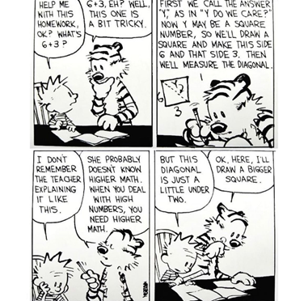
Exam questions

The following represents the pattern of a section of ticker tape attached to a trolley travelling at constant acceleration.
- Calculate the acceleration at which the trolley was moving.
- How many dots should we use when calculating the speed?
- Why don't we just use 2 dots to calculate the speed?
- What would be the effect on the pattern if the trolley was moving at constant speed?
- What would be the effect on the pattern if the trolley was moving faster?
- What would be the effect on the pattern if the trolley was moving more slowly?
- What would be the effect on the pattern if the trolley was stationary?

[2012 OL]
A student carried out an experiment to measure the acceleration of a moving trolley.
The student measured the initial velocity of the trolley and the final velocity of the trolley, along with another measurement. The student used these measurements to find the acceleration of the trolley.
- Draw a diagram to show how the student got the trolley to accelerate.
- Describe how the student measured the final velocity of the trolley.
- What other measurement did the student take?
- How did the student use the measurements to calculate the acceleration of the trolley?
- Give a precaution the student took to ensure an accurate result.

[2008 OL]
A student carried out an experiment to find the acceleration of a moving trolley.
The student measured the velocity of the trolley at different times and plotted a graph which was then used to find its acceleration. The table shows the data recorded.

velocity/ m s⁻¹ | 0.9 | 1.7 | 2.5 | 3.3 | 4.1 | 4.9
time/s | 0 | 2 | 4 | 6 | 8 | 10

- Describe, with the aid of a diagram, how the student measured the velocity of the trolley.
- Using the data in the table, draw a graph on graph paper of the trolley’s velocity against time.
Put time on the horizontal axis (X-axis).
- Find the slope of your graph and hence determine the acceleration of the trolley.

Worked solutions

[2008 OL]
- He measured the distance between 11 dots on the tape.
The time taken to cover that distance corresponded to the time for 10 intervals, where each interval was 1/50th of a second.
He calculated velocity using the formula velocity = distance/time.

- See graph
- The slope of the graph corresponds to the acceleration

Take any two points e.g. (0, 0.9) and (10, 4.9) and
use the formula:

Slope = acceleration = 0.4 m s⁻²

MEASUREMENT OF ACCELERATION USING TWO LIGHT GATES

APPARATUS: Ticker timer and tape, a.c. power supply, trolley, runway
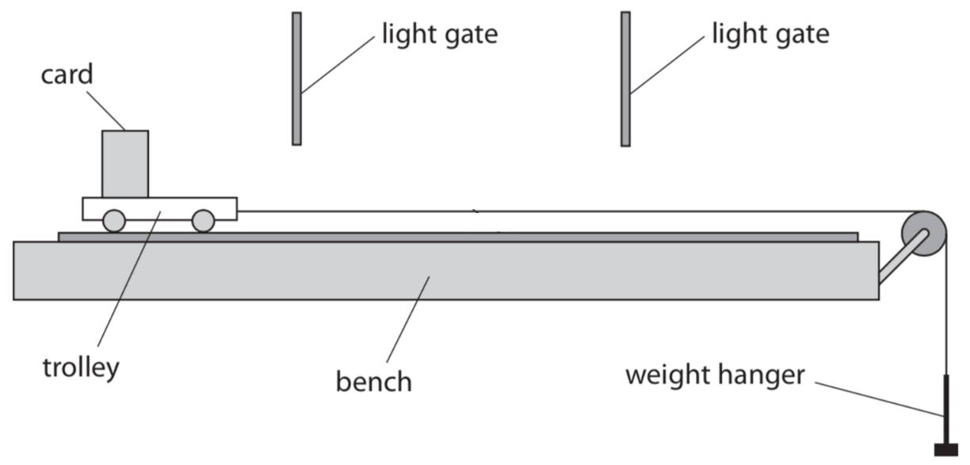
DIAGRAM

PROCEDURE

- Set up the apparatus as in the diagram.
Each lightgate (we used a BeeSpi V Light Gate) calculates the average velocity of the trolley as it passes by.

- Allow the trolley to accelerate down the runway.

- The first gate measures the initial velocity (u) and the second velocity measures the second velocity (v).

- Measure the distance (s) between the front of the first lightgate and the front of the second lightgate.

- The acceleration is found using the formula: v² = u²+2as

- Increase the rate of acceleration by adding more weights or by raising the back of the ramp to increase the slope. Repeat a number of times.

- Tabulate results below.

 | Initial velocity  (m s⁻¹) | Final velocity  (m s⁻¹) | Distance  (m s⁻¹) | $a=\frac{v^{2}-u^{2}}{2s}$ (m s⁻²)
Run #1
Run #2
Run #3
Run #4
Run #5

Acceleration due to gravity: ‘g’

In the absence of air resistance, all objects in freefall near the surface of the Earth will experience the same.
This acceleration is called acceleration due to gravity.
Its symbol is ‘g’.
The value of g on the surface of the Earth is 9.8 m s⁻².
Acceleration due to gravity is the acceleration which objects in freefall experience due to the gravitational attraction of the Earth.

We mention ‘on the surface of the earth’ because the value of g decreases as you move further away from the surface.
We can now use this value when using equations of motion.

Notes
- Some vector quantities (like initial velocity and displacement) may be in the upward direction while others (like g) may be acting downwards. The direction of each vector needs to be acknowledged in the equations we use and this acknowledgement occurs via the sign of the quantity. All vectors acting upwards have one sign (usually positive) while those acting in the downwards direction have to have the opposite sign, This is why you will often see g written as (-) 9.8 m s⁻², but you should try to avoid making g negative for every question – we only make it negative if there are other quantities in the same equation which are acting in the opposite direction.

- If an object is released from rest it means that initial velocity is zero (u = 0).

- At the highest point of a trajectory, the (instantaneous) velocity is zero (v = 0). This is because at that particular moment the object is not moving upwards or downwards.

- Even though the velocity is zero at the highest point, the object is still accelerating at 9.8 m s⁻².

- Finally – and this is a biggie:
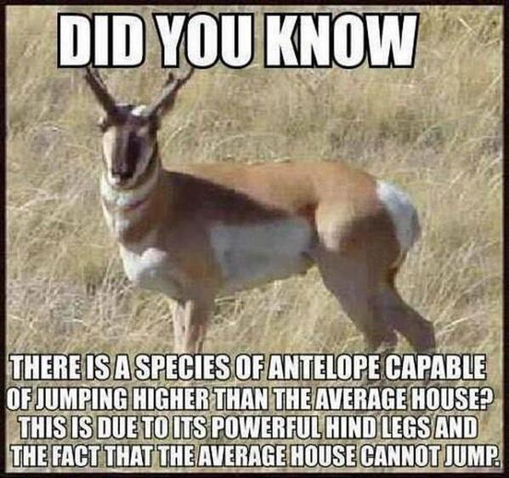
A stone which has been thrown upwards is actually accelerating downwards!

This is because the direction that an object is accelerating in is determined by the direction of the force which caused that acceleration. Students can often find this difficult to accept. The stone is accelerating downwards because the force causing the change in velocity (the gravitational force) is acting downwards. Why is this so confusing? Well up to now our examples of accelerating objects are usually cars where it just so happens that the force is in the same direction as the direction in which the car is moving so we mistakenly end up associating the direction of acceleration with direction of motion when what we should be doing is associating the direction of acceleration with direction of the (net) force.
Worked examples

2015 Question 5 [Ordinary level]
A small stone is thrown straight up from the ground with an initial speed of 20 m s⁻¹.
Calculate the height it has reached after two seconds.
u = 20 m s^{–1}  v =  a = - 9.8 m s^{–2}  s = ?  t = 2 s | s = ut + ½ at²  s = (20)(2) - ½ (9.8)(2)²  s = 20.4 m
An astronaut is on the surface of the moon, where the acceleration due to gravity is 1.6 m s^{–2}.
The astronaut throws a stone straight up with an initial speed of 25 m s^{–1}.
Calculate the highest point reached by the stone.
u = 25 m s^{–1}  v = 0  a = - 1.6 m s^{–2}  s = ?  t = | v² = u² + 2as  ⇒ 0 = (25)² + 2 (-1.6)(s)  ⇒ s = 195.3 m.
Calculate how high the astronaut can throw the same stone with the same initial speed of 25 m s^{–1} when on the surface of the earth, where the acceleration due to gravity is 9.8 m s^{–2}.
u = 25 m s^{–1}  v = 0  a = - 9.8 m s^{–2}  s = ?  t = | v² = u² + 2as  ⇒ 0 = (25)² + 2 (-9.8)(s)  ⇒ s = 31.9 m.
A student throws a ball vertically upwards. The ball leaves the student’s hand at a velocity of 7 m s⁻¹ when it is 130 cm above the ground.
Calculate the maximum height, above the ground, the ball will reach
u = 7 m s^{–1}  v = 0  a = - 9.8 m s^{–2}  s = ?  t = | v² = u²+ 2as  ⇒ 0 = (7)² + 2(-9.8)(s)  ⇒ s = 2.50 m  ⇒ max. height = 2.5 + 1.30 = 3.8 m
Remember the importance of signs!
Calculate the time taken for the ball to hit the ground after its release in the previous question.
u = 7 m s^{–1}  v =  a = - 9.8 m s^{–2}  s = - 1.3 m s⁻²  t = | s = ut + ½ at²  ⇒ -1.30 = 7t – ½ (9.8)t²  ⇒ 4.9t² - 7t-1.3 = 0  ⇒ Solve this quadratic equation to get t = 1.59 s

Deriving the three equations of motion

$$v=u+at$$ | $a=\frac{v-u}{t}$ $at=v-u$ $u+at=v$
$$s=ut+\frac{1}{2}at^{2}$$ | Two assumptions: s = (v_{average})(time) AND $v_{average=}\frac{u+v}{2}$  s = (v_{average})(time) But $v_{average=}\frac{u+v}{2}$  Therefore $s=(\frac{u+v}{2})t$ $2s=(u+v)t$  But v = u + at $2s=(u+u+at)t$ $2s=2ut+at^{2}$  $$s=ut+\frac{1}{2}at^{2}$$
$v^{2}=u^{2}$+2as | $v=u+at$ $(v^{2})={(u+at)}^{2}$ $v^{2}=u^{2}+2uat+a^{2}t^{2}$  $v^{2}=u^{2}+2a(ut+\frac{1}{2}at^{2})$ $v^{2}=u^{2}+2as$

And yes, using calculus is perfectly acceptable.

$$v=u+at$$ | $v^{2}=u^{2}$+2as | $$s=ut+\frac{1}{2}at^{2}$$
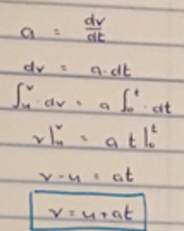 | 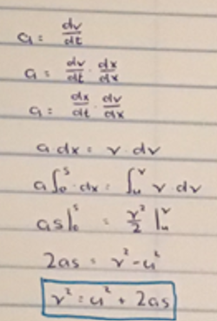 | 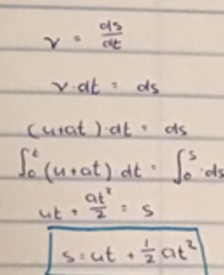

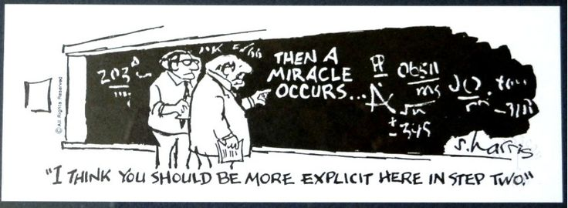
If possible, try to avoid the following:

MEASUREMENT OF ACCELERATION DUE TO GRAVITY (g)

APPARATUS : Millisecond timer, metal ball, trapdoor and electromagnet.

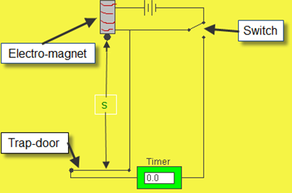
DIAGRAM

PROCEDURE

- Set up the apparatus as shown. The millisecond timer starts when the ball is released and stops when the ball hits the trapdoor.

- Measure the distance s using a metre stick.

- Flick the switch to release the ball and record the time t from the millisecond timer.

- Repeat for different values of s.

- Draw a graph of s against t² and use the slope to find a value for g.

RESULTS

s (m)
t (s)
t² (s²)

CONCLUSION
When we plotted the graph, the slope worked out to be 4.85, which resulted in a value for g of 9.9 m s⁻², which is pretty damn close to the theoretical value of 9.8 m s⁻². Conclusion? We rock!

PRECAUTIONS / SOURCES OF ERROR
- For each height s repeat three times and take the smallest time as the correct value for t.
- Place a piece of paper between the ball bearing and the electromagnet to ensure a quick release.
- Remember to convert from milliseconds to seconds.

NOTE
Both points 1 and 2 above are associated with the problem that even though you switch off the power for the electromagnet (and in so doing switch on the timer) it will not lose its magnetism immediately, therefore the ball will not fall straight away. This means that the reading on the timer will always be (slightly) longer than the time for which the ball was dropping.


Graph of displacement (s) against t²

Theory questions

Draw a labelled diagram of the apparatus used in the experiment. | See diagram. To include timer, ball and release mechanism, trap door/pressure plate
Indicate the distance s on your diagram. | From bottom of ball to top of trap door/pressure plate
Describe how the distance s was measured.

Describe how the time interval t was measured. | When we flicked the switched it turned on the timer and this remained on until the ball fell through the trap-door at the bottom. The time was then read from the timer.
Calculate a value for the acceleration due to gravity by drawing a suitable graph based on the recorded data.

Give two precautions that should be taken to ensure a more accurate result. | measure from bottom of sphere; avoid parallax error; for each value of s take several values for t / min t reference; adjust ‘sensitivity’ of trap door; adjust ‘sensitivity’ of electromagnet (using paper between sphere and core); use large values for s (to reduce % error); use millisecond timer
Give two ways of minimising the effect of air resistance in the experiment. | Small (object)/ smooth(object)/ no draughts / distances relatively short / heavy (object) / dense / spherical/ aerodynamic

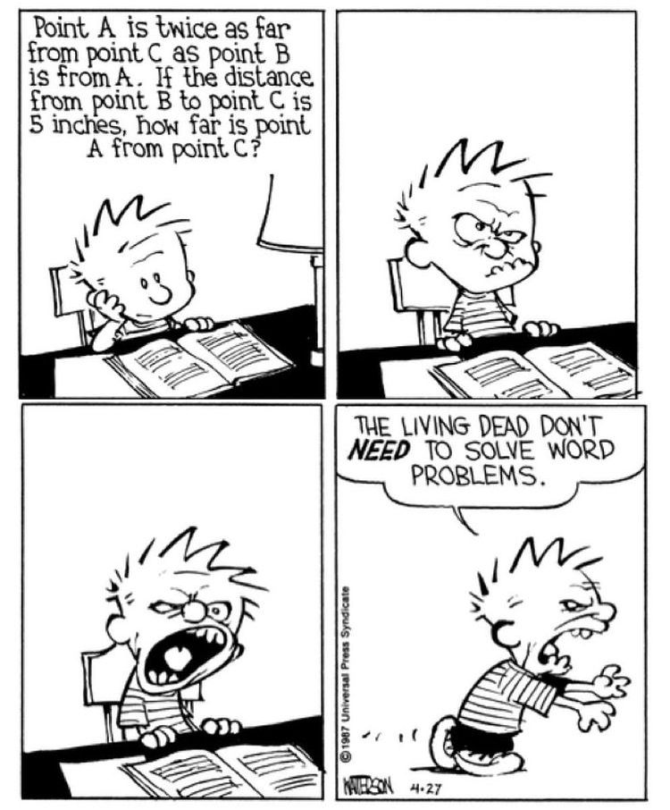

Exam questions
OL: 2013, 2009, 2002 HL: 2019, 2009, 2004

2019 HL

In an experiment to determine the acceleration due to gravity, the time t for an object to fall from rest through a distance s was measured. The procedure was repeated for a series of values of s.
The following data were recorded.

s (cm) | 30.0 | 40.0 | 50.0 | 60.0 | 70.0 | 80.0 | 90.0
t (ms) | 250 | 285 | 310 | 345 | 380 | 400 | 435

- Draw a labelled diagram of the apparatus used in the experiment.
- Between which points was the distance s measured?
- Describe how the time t was measured.
- Draw a suitable graph that can be used to determine the acceleration due to gravity g.
- Hence determine g.
- A small, dense ball was used as the object in this experiment. State an advantage of using this type of ball.

2009 HL
In an experiment to measure the acceleration due to gravity, the time t for an object to fall from rest through a distance s was measured. The procedure was repeated for a series of values of the distance s. The table shows the recorded data.
s/ cm | 30 | 50 | 70 | 90 | 110 | 130 | 150
t/ms | 247 | 310 | 377 | 435 | 473 | 514 | 540

- Draw a labelled diagram of the apparatus used in the experiment.
- Indicate the distance s on your diagram.
- Describe how the time interval t was measured.
- Calculate a value for the acceleration due to gravity by drawing a suitable graph based on the recorded data.
- Give two ways of minimising the effect of air resistance in the experiment.

2004 HL
In an experiment to measure the acceleration due to gravity g by a free fall method, a student measured the time t for an object to fall from rest through a distance s.
This procedure was repeated for a series of values of the distance s.
The table shows the data recorded by the student.
s/cm | 30 | 40 | 50 | 60 | 70 | 80 | 90
t/ms | 244 | 291 | 325 | 342 | 371 | 409 | 420
- Describe, with the aid of a diagram, how the student obtained the data.
- Calculate a value for the acceleration due to gravity g by drawing a suitable graph based on the recorded data.
- Give two precautions that should be taken to ensure a more accurate result.

Worked solutions

2019

2009

2004

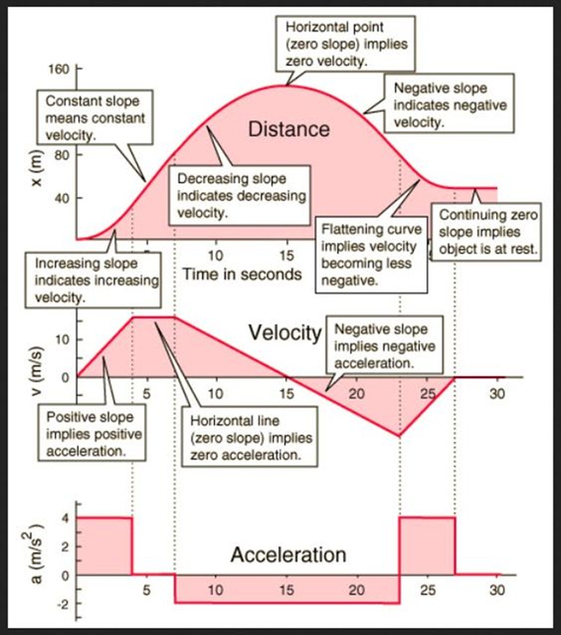

The science of learning quiz: Part 7

      - Explain the difference between active study and passive study (and why is passive study a misnomer?)

      - Using an ineffective study technique will result in minimal learning. But worse that that it can actually be counter-productive. Can you say why?

      - Complete the following sentence and explain its significance:
“Practice does not make perfect – it makes _________________”.

Answers

            - Explain the difference between active study and passive study (and why is passive study a misnomer?)
You are engaging in active study if your brain is heavily involved in the study (are you interrogating the material?). To an outsider or parent looking in, it can be difficult to tell whether the student is engaged in active or passive study, but if it’s passive study then it’s really only giving the illusion of study and there is unlikely to be any significant retention of information. Active study uses more cognitive resources (this is a fancy way of saying that your brain is working harder) which is why we don’t like doing it.
Teaching others as an example of studying through Active Recall: Two minute YouTube video

The following is a nice way to summary this: Learning happens when students have to think hard about what they’re studying.

            - Using an ineffective study technique will result in minimal learning. But worse that that it can actually be counter-productive. Can you say why?
It often leads to illusions of competence (discussed earlier) so you think that you know when you really don’t.
And because you think you know it you don’t bother with any of the other, more effective, study techniques.

            - Complete the following sentence and explain its significance:
“Practice does not make perfect – it makes _________________”.
Practice does not make perfect – it makes permanent. In other words using the same ineffective study technique for a long time (perhaps years) just means that it is going to be very difficult to break this habit in the future. You can spend all day exercising in order to become a better sprinter, but if it’s the wrong type of exercise (eg jogging) then it’s not likely to be very useful to improve your sprinting.

Working hard but ineffectively just makes you very good at working ineffectively.



3: FORCE

Something to think about

“… in spite of the strenuous efforts of physicists and philosophers, the notion of mass, although fundamental in physics is … shrouded in mystery.”
Max Jammer, Concepts of Mass in Contemporary Physics and Philosophy, 2000
See also the Royal Institution’s The Concept of Mass lecture on YouTube

- Approximately 96% of the mass in the universe is missing. We know it has to be out there, but we can’t find it. We call it ‘Dark Matter’. This term is a placeholder for “We actually have no idea”.

- If only one force acts on an object, what happens the object (your answer needs to be as specific as possible)?

- There is a gravitational force of attraction between you and the planet you are standing on.
Which is greater; the gravitational force that the planet exerts on you or the gravitation force which you exert on the planet (or is there a third option)?

- There is book resting on a table. There is a gravitational force pulling the book down. Yet the book is not accelerating downwards. Therefore there must be an equal force opposing this gravitational force. What is this force?
You can’t say ‘the table’; a table is not a force – a table is a table.
- Show how each of Newton’s three laws of motion play a part in explaining how a player can develop concussion when tackled.

- It’s easier to lift a stone on the moon than on Earth but you’re as likely to break your toe by kicking it on the moon as on Earth. Why?

- Anybody remember the story of the apple that fell on Newton’s head?
What was so significant about that story?

FYI: An apple weighs approximately 1 newton.

Student notes

Definition of a force
A force is anything which has the potential to cause an object to accelerate.
The unit of force is the newton (N).

Definition of the newton
One newton is that force which causes a body of mass 1 kg to undergo an acceleration of 1 m s⁻².

What is mass?
The mass of an object is a measure of its inertia.
The inertia of an object in turn is a measure of the resistance which the object has to a change in its velocity.

The unit of mass is the kilogram (kg).

Relationship between force, mass and acceleration

(net) force = mass × acceleration
F_{net} = ma

Always remember: “AN UNBALANCED FORCE PRODUCES AN ACCELERATION”

2019 Question 5 Ordinary Level  A force of 2500 N acts on a car of mass 1000 kg.  Calculate the acceleration of the car. | $a=\frac{F}{m}=\frac{2500}{1000}$ = 2.5 m s⁻².

TO SHOW THAT ACCELERATION IS PROPORTIONAL TO THE FORCE CAUSING IT

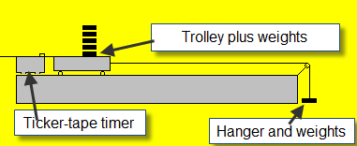
APPARATUS
Set of weights, electronic balance, trolley, ticker-tape timer and tape.

DIAGRAM

PROCEDURE
- Set up the apparatus as shown in the diagram.

- Start by taking one weight from the trolley and adding it to the hanger at the other end.

- Note the weight at this end (including the weight of the hanger) using an electronic balance.

- Release the system which allows the trolley to accelerate down the track.

- Use the ticker-tape timer to calculate the acceleration.

- Repeat these steps about seven times, each time taking a weight from the trolley and adding it to the other end.

- Record the results for force and acceleration in a table.

- Draw a graph of force (on the y-axis) against acceleration (on the x-axis). T

- The slope of the graph corresponds to the mass of the system (trolley plus hanger plus all the weights). See calculations on graph page.

RESULTS

Force (N)
Acceleration (m s⁻²)

CONCLUSION
Our graph resulted in a straight line through the origin, verifying that the acceleration is proportional to the force, as the theory predicted.

PRECAUTIONS / SOURCES OF ERROR
- When adding weights to the hanging masses, you must take them from the top of the trolley.
- Ensure that the runway in smooth, free of dust, and does not sag in the middle.
- Ensure that the runway is tilted just enough for the trolley to roll at constant speed when no force is applied.

Graph to verify F = ma

Why must the hanging weights be taken from on top of the trolley?
Answer: so that the mass of the system can be kept constant
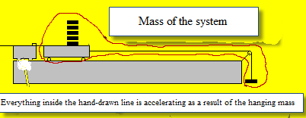

We’re looking to investigate the relationship between the acceleration of an object and the force which caused it.
The force which is causing the acceleration is the hanging weights. What mass is accelerating as a result of these weights dropping?
Well obviously the trolley plus the weights sitting on it are accelerating, but not just that; the hanging weights themselves are also accelerating, so the total mass accelerating as a result of the hanging weights is:
trolley + weights sitting on trolley + hanging weights
Now if we’re looking to investigate the relationship between the acceleration of an object and the force which caused it we need to keep all other variables constant. In this case one other variable is the mass which is ₎being accelerated. The only way to increase the hanging weights while keeping the mass of the system constant, is to transfer weights from the trolley to the hanging weights.

Theory questions
Draw a labelled diagram of the apparatus you used.
State what measurements were taken during the experiment. | We measured mass, velocity and distance
How did you measure the applied force? | By weighing the masses and hanger on an electronic balance (set to newtons).
Describe the steps involved in measuring the acceleration of the body.
What does your graph tell you about the relationship between the acceleration of the body and the force applied to it? | They are proportional.
How does the graph tell you this? | We got a straight line through the origin
Calculate the slope of your graph and hence determine the mass of the body. | Slope of the graph corresponds to the mass of the object (assuming force is on the vertical axis).
On a trial run of this experiment, a student found that the graph did not go through the origin.  Suggest a reason for this. | There was too much friction or the track was too steep.
How did you minimise the effect of friction during the experiment? | Brushed the track, oiled the wheels
Describe how the apparatus should be adjusted so that the graph would go through the origin. | Brushed the track or lowered the track.
Give one precaution that the student took during the experiment. | Brushed the track or lowered the track.

Related exam questions

2015 OL, 2010 OL, 2005 OL, 2003 OL 2010 HL

[2005 OL]
In an experiment to investigate the relationship between force and acceleration a student applied a force to a body and measured the resulting acceleration. The table shows the measurements recorded by the student.
Force /N | 0.1 | 0.2 | 0.3 | 0.4 | 0.5 | 0.6 | 0.7
acceleration /m s^{–2} | 0.10 | 0.22 | 0.32 | 0.44 | 0.55 | 0.65 | 0.76

- Draw a labelled diagram of the apparatus used in the experiment.
- Outline how the student measured the applied force.
- Plot a graph, on graph paper of the acceleration against the applied force. Put acceleration on the horizontal axis
- Calculate the slope of your graph and hence determine the mass of the body.
- Give one precaution that the student took during the experiment.

[2010]
F/N | 0.20 | 0.40 | 0.60 | 0.80 | 1.00 | 1.20 | 1.40
a/m s^{–2} | 0.08 | 0.18 | 0.28 | 0.31 | 0.45 | 0.51 | 0.60
In an experiment to investigate the relationship between the acceleration of a body and the force applied to it, a student recorded the following data.

- Describe the steps involved in measuring the acceleration of the body.
- Using the recorded data, plot a graph to show the relationship between the acceleration of the body and the force applied to it.
- What does your graph tell you about this relationship?
- Using your graph, find the mass of the body.
- On a trial run of this experiment, a student found that the graph did not go through the origin.
Suggest a reason for this.
- Describe how the apparatus should be adjusted, so that the graph would go through the origin.

Worked solutions

2005 OL
- Draw a labelled diagram of the apparatus used in the experiment.
See diagram.
- Outline how the student measured the applied force.
The applied force corresponds to the weight of the hanger plus weights; the value of the weights is written on the weights themselves.

- Plot a graph,
See graph.

- Calculate the slope of your graph and hence determine the mass of the body.
.
Substituting in two values (from the graph, not the table) should give a slope of approximately 0.9.
This means that the mass is 0.9 kg.
- Give one precaution that the student took during the experiment.
Oil the trolley wheels, dust the runway, oil the pulley.

2010
- Describe the steps involved in measuring the acceleration of the body.
Measure/calculate the initial velocity/speed using light gates or ticker tape timer.
Measure/calculate the velocity/speed again (t seconds later)
Measure time interval from initial to final velocities / Measure distance between light gates
Use formula v = u + at or v² = u²+2as to calculate acceleration.

- Plot a graph to show the relationship
Label axes correctly on graph paper
Plot six points correctly
Straight line
Good distribution

- What does your graph tell you about this relationship?
Acceleration is proportional to the applied force.

- Using your graph, find the mass of the body.
The mass of the body corresponds to the slope of the graph = 2.32 kg [range: 2.1 - 2.4 kg]

- On a trial run of this experiment, a student found that the graph did not go through the origin.
Suggest a reason for this and
Friction / dust on the track slowing down the trolley.

- Describe how the apparatus should be adjusted, so that the graph would go through the origin.
Elevate/adjust the track/slope

Who or what is a net force?

If you did Business Studies in Junior Cert you may already have encountered the concept of net salary; I get my gross salary from the Department of Education. They then add on some more money because of various extra qualifications I have and also subtract various taxes. What I am left with after all this is called my net salary.
It’s the same for forces. To calculate the net force you add up all the forces that are in the same direction and subtract those that are in the opposite direction.

2020 Question 6 [Ordinary Level]  Calculate the resultant (net) force on the 9 kg  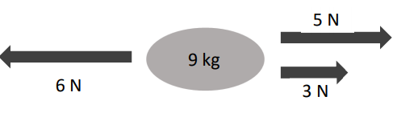  object in the diagram above. In what direction does it act? | There is a force of 6 N to the left and a total of 8 N (5 N + 3 N) to the right, so the net force is 8 N – 6N = 2 N towards the right
Calculate the acceleration of the 9 kg object. | F_{net} = 2 N  m = 9 kg  a = ?  F_{net} = ma $a= \frac{F_{net}}{m}= \frac{2}{9}$ = 0.22 m s⁻²

2011 Question 5 [Higher level]  A car of mass 1500 kg is travelling at a constant velocity of 20 m s^{–1}.  What force is required to stop it in a distance of 50 m?  Solution  u = 20 m s^{–1}  v =  a = ?  s = 50 m  t = | We will need to use F = ma, but before we do that we first need to work out the acceleration.  v² = u² + 2as  0 = (20)² + 2(a)(50)  a = - 4 m s⁻²  The negative sign indicates that the acceleration is in the opposite direction to the initial velocity of the car.  F = ma  F = 1500a  F = 6000 N  The positive sign indicates that the force is in the same direction as the acceleration

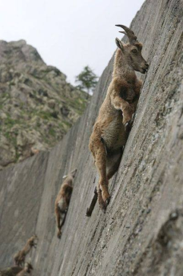
Friction

Friction is a force which opposes the relative motion between two objects.
Examples of friction: braking, walking

2020 Question 6 [Ordinary Level]
A car of mass 700 kg is at rest.
It accelerates at a constant rate for 6 seconds until it is travelling at a velocity of 18 m s^{–1}.
- Calculate the acceleration of the car.
- Calculate the net force on the car as it accelerates.

The engine of the car provides a driving force of 3000 N.
- Calculate the friction acting on the car.

Part (i) | u = 0  v = 18 m s^{–1}  a = ?  s =  t = 6 m  v = u + at $a=\frac{v-u}{t}=\frac{18-0}{6}$ = 3 m s⁻²
Part (ii) | F_{net} = ma = (700)(3) = 2100 N
Part (iii) | There are two forces acting on the car in this question. We know the driving force is 3000 N and we know that the net force is 2100 N. We can use this to calculate the friction force as follows:  F_{engine} – F_{friction} = 2100  F_{engine} – 2100 = F_{friction}  3000 – 2100 = F_{friction}  900 = F_{friction}
2007 Question 12 (a) [Higher Level]
A car of mass 750 kg is travelling east on a level road. Its engine exerts a constant force of 2.0 kN causing the car to accelerate at 1.2 m s^{–2} until it reaches a speed of 25 m s^{–1}.
- Calculate the net force acting on the car.
- Calculate the force of friction acting on the car.
- If the engine is then turned off, calculate how far the car will travel before coming to rest.

Part (i) | F_{net} = ma F_{net} = (750)(1.2) F_{net} = 900 N east.
Part (ii) | F_{net} = F_{big} – F_{small}  F_{net} = F_{engine} - F_{friction}  900 = 2000 - F_{friction} ⇒ F_{friction} = - 1100 N  The engine was exerting a force of 2000 N east. We made this a positive number, so the fact that we got a minus 1100 N for the force of friction it implies that the friction is opposite in direction to the engine force. Which is what we would expect.
Part (iii) | Friction causes deceleration: a = F ÷ m  Here we will use vuast, but we need to work out the acceleration a.  The only force acting on the car at this stage is the friction force.  $a=\frac{F}{m}$ $a=\frac{1100}{750}$ a = -1.47 ms⁻²  v² = u² + 2as  0 = 25² +2(-1.47) s s = 213 m  {Note that a is negative because in this context it represents a deceleration.}

2002 Question 6 [Ordinary Level]
The diagram shows the forces acting on an aircraft travelling horizontally at a constant speed through the air.

L is the upward force acting on the aircraft.
W is the weight of the aircraft.
T is the force due to the engines.
R is the force due to air resistance.

- What happens to the aircraft when the force L is greater than the weight of the aircraft?
- What happens to the aircraft when the force T is greater than the force R?
- The aircraft was travelling at a speed of 60 m s⁻¹ when it landed on the runway. It took two minutes to stop. Calculate the acceleration of the aircraft while coming to a stop.
- The aircraft had a mass of 50 000 kg. What was the force required to stop the aircraft?

Part (i) | It accelerates upwards.
Part (ii) | It accelerates forward.
Part (iv) | v = u + at ⇒ 0 = 60 + a (120) ⇒ a = - 0.5 m s⁻²  The minus sign indicates that the acceleration is opposite in direction to the initial velocity.
Part (v) | F = ma ⇒ F = 50 000 × 0.5 = 25 000 N.  Notice that we don’t need to put the minus sign in here.

Momentum
ρ = mv

Momentum = mass × velocity

The symbol of momentum is ρ; pronounced “row”
The unit of momentum is the kilogram metre per second (kg m s⁻¹) OR newton second (N s).

The principle of conservation of momentum

In any interaction, the total momentum before the interaction is equal to the total momentum afterwards provided no external forces act on the system.
(If you forget the bit in italics you lose half marks!)

There are three common scenarios which can be labelled Hit ‘n bounce, Hit ‘n stick and Explosion
we can represent it mathematically as follows:
(small mass by big vel = big mass by small vel)

- Hit ‘n bounce: It one object collides with another then
m₁u₁ + m₂u₂ = m₁v₁ + m₂v₂

Note that initial and final velocity in this context refers to velocity just before and immediately after impact.

- Hit ‘n stick: If one object collides with another and the two objects coalesce (stick together) then there is only one (common) velocity after collision, so the above equation becomes:

m₁u₁ + m₂u₂ = (m₁ + m₂)v₃

- Explosions
Momentum is a vector quantity which means that different directions much have different signs. This means that the following (seemingly crazy) idea is allowed: You can have a situation where we have two objects with no momentum beforehand and they end up with equal and opposite momentum afterwards. An example would be a bullet sitting in a rifle and if we ‘fire’ the gun, the bullet goes forward and the gun recoils in the opposite direction.
The first equation can therefore be reduced to the following where one of the velocities will turn out to be negative.
0 = (m₁v₁) + (m₂v₂)

Example 1  2003 Question 5 [Ordinary level]  What is the momentum of an object with a mass of 5 kg travelling at 10 m s⁻¹? | Solution  Momentum = mass × velocity  = 5 × 10 = 50 kg m s⁻¹.
Example 2 [2007 OL]
Two shopping trolleys each of mass 12 kg are on a smooth level floor.
Trolley A moving at 3.5 m s⁻¹ strikes trolley B, which is at rest.
After the collision both trolleys move together in the same direction.
Calculate the common velocity of the trolleys after the collision.
Solution  Total momentum before = Total momentum after  m₁u₁ + m₂u₂ = m₁v₁ + m₂v₂  (12)(3.5) + (12)(0) = m₁v₁ + m₂v₂  42 = m₃v₃  42 = 24v₃  v₃ = 42/24  v₃ = 1.75 m s⁻¹ | Comment  The two trolleys are moving off together afterwards so we can treat them as one object which has a combined mass of 24 kg and is moving at a velocity v₃.
Vectors are magic as we know but as with all magic you need to be very careful that you use it wisely.

One very important rule is that signs are really important. If you are lucky (like in the two worked examples above) then everything will be moving in the same direction and as a result you can give everything the same sign (keeping everything positive is the easiest option here).

BUT if some of the quantities are acting in different directions then you need to assign a direction to every quantity that is acting towards the right and the opposite sign to any quantities that are acting towards the left. Or sometimes, as in the question below, everything will be in the same direction (and therefore all positive) until you get to the answer. If that quantity then turns out to have a different sign it means that it is acting in the opposite direction to all the others.

A 5 kg gun is held stationary and fires a 100 g bullet at a velocity of 200 m s⁻¹. Find the velocity of the gun as it recoils.
Use a positive sign for any velocity or momentum that is acting towards the right and a negative sign for any quantities that are acting towards the left.
Solution  Total momentum before = Total momentum after  m₁u₁ + m₂u₂ = m₁v₁ + m₂v₂  (5)(0) + (0.1)(0) = (5)(v₁) + (0.1)(200)  - 5v₁ = 20  v₁ = - 4 m s⁻¹ | Comment  The child and boat were both at rest initially so total momentum beforehand is zero.  Notice that the final velocity is a negative number, indicating that the boat moves off in the opposite direction to the child. That’s the power of vectors my friend.

Example 4
2017 Question 5 [Higher level]

Sphere A of mass 400 g is travelling horizontally with a speed of 6 m s^{–1} when it collides with sphere B of mass 150 g travelling in the opposite direction with a speed of 9 m s^{–1}.
Sphere A comes to rest as a result of the collision.
Calculate the new velocity of sphere B.

Solution  m₁u₁ + m₂u₂ = m₁v₁ + m₂v₂  (0.4)(6) + (0.15)(-9) = (0.4)(0) + (0.15)(v)  v = 7 m s⁻¹ | Comment  In this case the speed of B is 9 m s⁻¹ but importantly it is moving in the opposite direction to A so we need to represent B’s velocity as – 9 m s⁻¹.

We tend to associate high momentum with objects moving fast, but it could just as easily be a very big slow-moving object – like the Bagger 293.

2021 Question 7 [Ordinary Level]
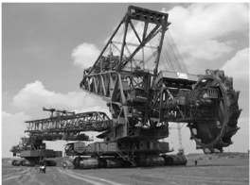
The Bagger 293 excavator is the world’s largest land vehicle, with a mass of 14200 tonnes.
(1 tonne = 1000 kg)
Bagger 293 has a maximum speed of 0.17 m s⁻¹.

- Calculate the momentum of Bagger 293 when it is moving at its maximum speed.
- Bagger 293 is moving when it picks up a stationary load of 2700 tonnes.
Would this cause its speed to increase or to decrease?
Explain your answer.

Part (i) | Mass of excavator = 14200 tonnes = 14000 × 10³ kg. velocity = 0.17 m s⁻¹.  Momentum =mv = (14200 × 10³)(0.17) = 2.4000000 kg m s⁻¹ = 2.4 × 10⁶ kg m s⁻¹
Part (ii) | Momentum = mass × velocity and this number will be the same before and after the excavator picks up a load assuming no external forces act.  Once it picks up a load its overall mass will increase so if its overall momentum remains constant then this must mean that velocity decreases.  This is assuming no external forces come into play – is this a realistic assumption?
2013 Question 6 [Ordinary Level] | Question: Explain how the principle of conservation of momentum applies in the case of a jet engine moving an aircraft.  Answer: The engine expels air in one direction. The momentum of this air is equal to the momentum of the aircraft moving in the opposite direction.

TO VERIFY THE PRINCIPLE OF CONSERVATION OF MOMENTUM

APPARATUS
Set of weights, electronic balance, trolley, ticker-tape timer and tape.

DIAGRAM
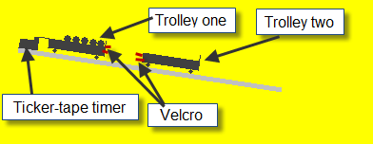
PROCEDURE
- Set up the apparatus as shown in the diagram. The track is tilted slightly so that the trolleys will move at constant velocity when given an initial push.

- Note the mass of both trolleys to begin with.

- Both trolleys are initially at rest.

- Trolley one is given an initial push such that it moves at constant velocity until it collides with Trolley two whereupon they will join together (because of the velcro) and move off as one combined mass

- Use the ticker-tape to calculate the velocity of Trolley one before the collision and the velocity of the combined mass after the collision.

- Repeat the experiment a few times, each time adding masses from one trolley to the other .

- Record the results in the table and for each run calculate the total momentum before and after the collision.

RESULTS AND CALCULATIONS:

 | MOMENTUM BEFORE |  |  |  |  |  |  | MOMENTUM AFTER
 |  |  |  |  | Total Before |  |  |  |  | Total After
 | m₁ | u₁ | m₁u₁ | m₂u₂ | m₁u₁+m₂u₂ |  | m₂ | (m₁ + m₂) | v₃ | (m₁ + m₂)v₃
Run 1
Run 2
Run 3

CONCLUSION
After completing the experiment we found that in each case the total momentum before the collision equalled the total momentum after the collision (within the limits of experimental error), in agreement with the theory.

SOURCES OF ERROR / PRECAUTIONS
- Ensure that the runway in smooth, free of dust, and does not sag in the middle.

- Ensure that the runway is tilted just enough for the trolley to roll at constant speed.
Theory questions

Draw a labelled diagram of the apparatus used in the experiment. | Two trolleys, means of coalescing trolleys, timing apparatus
How did the student measure the mass of the trolleys? | By weighing it on an electronic balance.
Describe how the time interval of 0.2 s was measured. | It corresponded to 10 intervals on the ticker-tape.
Describe how the student measured the velocity v of the bodies after the collision. | Time between dots = 0.02 secs  We measured the distance for 10 intervals so the time was 10 × 0.02 = 0.2 seconds.  Velocity = distance ÷ time
When carrying out this experiment the student ensures that there is no net external force acting on the bodies.  What are the two forces that the student needs to take account of to ensure this? | Gravitational and frictional force {note that the word “gravity” may not be acceptable}  By sloping the track slightly so that the gravitational force = frictional force  OR by using a level air-track
Describe how the student reduced the effects of these forces. | Adjust gradient of track, lubricate trolley wheels, polish/brush track, clear holes (air track), etc.
How did the student know that body A was moving at constant velocity? | Dots on the ticker tape were equally spaced / same time interval shown by both light gates
How could the accuracy of the experiment be improved? | Use digital balance / select more dots / select greater distance/displacement /avoid parallax error
What adjustments did the student make to the apparatus so that body A would move at constant velocity?

Related exam questions
HL: 2018, 2014, 2011, 2005 OL: 2016, 2006, 2011

- [2011]
A student carried out an experiment to verify the principle of conservation of momentum.
The student adjusted the apparatus till a body A was moving at a constant velocity u.
It was then allowed to collide with a second body B, which was initially at rest, and the two bodies moved off together with a common velocity v.
mass of body A | 230 g
mass of body B | 160 g
velocity u | 0.53 m s^{–1}
velocity v | 0.32 m s^{–1}

The following data were recorded:
- Draw a labelled diagram of the apparatus used in the experiment.
- What adjustments did the student make to the apparatus so that body A would move at constant velocity?
- How did the student know that body A was moving at constant velocity?
- Describe how the student measured the velocity v of the bodies after the collision.
- Using the recorded data, show how the experiment verifies the principle of conservation of momentum.
- How could the accuracy of the experiment be improved?

- [2014]
The following is part of a student’s report on an experiment to verify the principle of conservation of momentum.
Mass of body A | 325.1 g
Mass of body B | 349.8 g
Velocity of body A before the collision | 0.84 m s^{–1}
Velocity of bodies A and B after the collision | 0.41 m s^{–1}
“I ensured that no net external forces acted on body A or body B. When I released body A it was moving at a constant velocity; body B was at rest. I allowed body A to collide with body B and they moved off together after the collision.”

The following data was recorded:
- Draw a labelled diagram of the apparatus used in the experiment.
- State what measurements the student took and how these measurements were used to calculate the velocities.
- Using the recorded data, show how the experiment verifies the principle of conservation of momentum.
- When carrying out this experiment the student ensures that there is no net external force acting on the bodies.
What are the two forces that the student needs to take account of to ensure this?
- Describe how the student reduced the effects of these forces.

Conservation of momentum maths questions
In an experiment to verify the principle of conservation of momentum, body A was set in motion with a velocity u. It collided with body B, which was initially at rest. Bodies A and B then moved with a common velocity v. The following data were recorded.
Using the recorded data, show how the experiment verifies the principle of conservation of momentum.
2018
Mass of body A = 360.7 g
Mass of body B = 340.9 g
Distance travelled by A for 0.12 s before the collision = 161 mm
Distance travelled by A and B for 0.12 s after the collision = 83 mm

2005
Mass of body A = 520.1 g
Mass of body B = 490.0 g
Distance travelled by A for 0.2 s before the collision = 10.1 cm
Distance travelled by A and B together for 0.2 s after the collision = 5.1 cm

Solutions
2018
Mass of body A = 360.7 g
Mass of body B = 340.9 g
Distance travelled by A for 0.12 s before the collision = 161 mm
Distance travelled by A and B for 0.12 s after the collision = 83 mm

$u=\frac{0.161}{0.12 }$ = 1.342 m s⁻¹  $v=\frac{0.083}{0.12 }$ = 0.692 m s⁻¹ | p = mv  Momentum before collision = (0.3607)(1.342)  = 0.484 kg m s⁻¹  Combined mass afterwards = 0.7016 kg  Momentum after collision = (0.7016)(0.692)  = 0.485 kg m s-1  p₁ is approximately equal to p₂
2014
Mass of body A = 325.1 g
Mass of body B = 349.8 g
Velocity of body A before the collision = 0.84 m s^{–1}
Velocity of bodies A and B after the collision = 0.41 m s^{–1}

Momentum before collision = 0.3251 × 0.84 = 0.273 kg m s^{–1}
Momentum after collision = (0.3251 + 0.3498)(0.41) = 0.277 kg m s^{–1}
0.273 kg m s^{–1} ≈ 0.277 kg m s^{–1}

2011
The following data were recorded:
mass of body A ........... = 230 g
mass of body B ........... = 160 g
velocity u .................... = 0.53 m s^{–1}
velocity v .................... = 0.32 m s^{–1}

momentum = mass × velocity
Momentum before collision = (0.230)(0.53) = 0.1219 kg m s⁻¹
Combined mass afterwards = 0.390 kg
Momentum after collision = (0.390)(0.32) = 0.1248 kg m s⁻¹
0.1219 kg m s^{–1} ≈ 0.1248 kg m s^{–1}

2005
Mass of body A = 520.1 g
Mass of body B = 490.0 g
Distance travelled by A for 0.2 s before the collision = 10.1 cm
Distance travelled by A and B together for 0.2 s after the collision = 5.1 cm

Velocity before: v = s/t = 0.101/0.2  u = 0.505 m s⁻¹  Combined velocity after the collision.  v = 0.051/0.2  v = 0.255 m s⁻¹ ≈ 0.26 m s⁻¹ | Momentum before  p = mv = (0.5201)(0.505) = 0.263 ≈ 0.26 kg m s⁻¹  Momentum after  p = mv = (0.5201 + 0.4900)(0.255)  p = 0.258 ≈ 0.26 kg m s⁻¹  Momentum before ≈ momentum after

Newton’s laws of motion

Our understanding of forces and motion is summarised in Newton’s three laws of motion (plus his universal law of gravitation which we will encounter in a later chapter).

- Newton’s first law of motion states that every object will continue to travel at constant velocity unless an (unbalanced) external force acts on it.

- Newton’s second law of motion states that the rate of change of an object’s momentum is directly proportional to the force which caused it, and takes place in the direction of the force.
Exam tip: don’t forget to use the phrase ‘rate of’ change – it’s easy to leave it out and end up with half marks.

- Newton’s third law of motion states that when objects interact they exert equal but opposite forces on each other.

These laws can be summarised as follows:
The first law is just “What happens if there isn’t a net force”, the second law is “What happens if there is”. And the third law is “You should see the other guy!”

The free-will problem

We have a problem. It’s a big problem. If every single particle (including atoms) moves as a result of forces acting on it, and our own brains are composed only of atoms (which in turn follow these laws) how then do we have free will? Or is it possible that we don’t actually have free will after all? And if we don’t, what implication would this have? How would it knowledge of this affect how we judge criminal acts? This is not just me being silly (for once). It is a problem that very educated folk have been struggling with for a long, long time and indeed many very sensible and clever (some even both) people believe that free will is a myth.
Apparently even Einstein didn’t to believe in free will. He used to say that if the moon was able to think, it would believe that it was moving of its own accord.

The fact that an opinion has been widely held is no evidence whatever that it is not utterly absurd; indeed in view of the silliness of the majority of mankind, a widely spread belief is more likely to be foolish than sensible. -- Bertrand Russell

2019 HL Question 5
A book is decelerating as it moves to the right on a horizontal table.
Draw a labelled diagram to show the forces acting on the book as it moves across the table.
Include in your diagram the direction of motion and direction of acceleration (this last bit wasn’t in the original question. I’ve added it in because it is such an important concept in this chapter).

Solution
This is a lovely question for illustrating the fact that an object can be moving in one direction but accelerating in the opposite direction.
Why?
One more time for the people at the back – because the direction of acceleration is determined by the direction of the net force causing that acceleration (and not by the direction of motion).
If the book is decelerating then the force causing this deceleration must be in the opposite direction to its motion, so we need to put in an arrow pointing left.
We refer to this as a ‘free body diagram’.

Note that the end of the force arrows are in contact with the object (drawing).
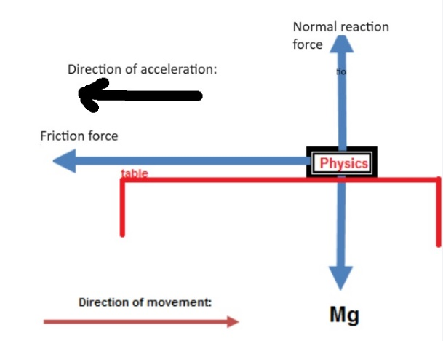

The term ‘decelerate’ or ‘deceleration’ only adds to the confusion (which is why this is – hopefully – the only time I use that term here). Here in physics land we try not to use it. It is always an ‘acceleration’ (because the velocity is changing). It’s just that sometimes the acceleration is in the same direction as the direction of motion (e.g. a racing car moving off) and sometimes the acceleration is the opposite direction to the direction of motion (e.g. a football which is moving upwards or, as in this case, a book sliding to the right but acted upon by friction which is in the opposite direction to direction of motion).

2011 Question 6 [Ordinary Level]
A car of mass 1400 kg was travelling with a constant speed of 15 m s⁻¹ when it struck a tree and came to a complete stop in 0.4 s.
- State Newton’s first law of motion.
- Draw a diagram of the forces acting on the car before it hit the tree.
- Calculate the acceleration of the car during the collision.
- Calculate the net force acting on the car during the collision.
- A back seat passenger could injure other occupants during a collision.
Explain, with reference to Newton’s laws of motion, how this could occur.
- How is this risk of injury minimised?

Part (i) | A body will remain at rest or moving at a constant velocity unless acted on by an (external) force,
Part (ii)
Part (iii) | v = u + at $a=\frac{v-u}{t}$ $a=\frac{0-15}{0.4}$ a = - 37.5 m s⁻²
Part (iv) | F_{net} = ma F_{net} = 1400 × 37.5 = 52500 N
Part (v) | Even though the car comes to a stop the back-seat passenger will continue to move forward (from Newton’s first law of motion) and so could collide with someone in the front.
Part (vi) | By wearing a seat belt.
Further activities

2009 Question 6 [Ordinary Level]
- The diagram shows the forces acting on a train which was travelling horizontally.
A train of mass 30000 kg started from a station and accelerated at 0.5 m s⁻² to reach its top speed of 50 m s⁻¹ and maintained this speed for 90 minutes.
As the train approached the next station the driver applied the brakes uniformly to bring the train to a stop in a distance of 500 m.
Calculate how long it took the train to reach its top speed.
- Calculate how far it travelled at its top speed.
- Calculate the acceleration experienced by the train when the brakes were applied.
- What was the force acting on the train when the brakes were applied?
- Name the force A and the force B acting on the train, as shown in the diagram.
- Describe the motion of the train when the force A is equal to the force T.
- Sketch a velocity-time graph of the train’s journey.

Part (i)  u = 0  v = 50 m s^{–1}  a = 0.5 m s^{–2}  s =  t = ? | v = u + at  50 = 0 + 0.5t  t = 50/0.5 = 100 s
Part (ii)  u = 0  v = 50 m s^{–1}  a = 0.5 m s^{–2}  s =  t = | s = ut + ½ at² (but a = 0) so we just use s = ut  90 minutes = (90×60) = 540 seconds  s = ut = 50 × (540) = 270000 m
Part (iii)  u = 50 m s^{–1}  v = 0  a = ?  s = 500 m  t = | v² = u² + 2as  0 = 50² + 2a(500)  a = −2500÷1000 = − 2.5 m s⁻¹  The minus sign indicates that the acceleration is opposite in direction to the initial velocity.
Part (iv) | F = ma  F = 30000 × 2.5 = 75000 N = 75 kN  Notice that force and acceleration both have the same sign (both positive) indicating that they are both in the same direction. We could have left the acceleration as a negative number, in which case the force would be a negative number also, once again indicating that they are both in the same direction.
Part (v) | A = friction/retardation / resistance to motion  B = weight / force of gravity
Part (vi) | The train will move at constant speed
Part (vii)

Terminal velocity – it’s all about forces
Air resistance acting on a skydiver in freefall is an example of a variable force. As the diver’s velocity increases she moves through a greater volume of air every second, therefore the air resistance acting against her also increases. Initially this air resistance is less than the gravitational force and so the diver continues to accelerate downwards until the upward air resistance eventually equals (in magnitude) the downward gravitational force. The diver will no longer accelerate at this point but will instead continue at whatever velocity she had at the instant that the two forces were equal. This is terminal velocity, and is approximately 100 m s⁻¹.

2003 Question 12 (a) [Higher Level]
- State Newton’s second law of motion.
A skydiver falls from an aircraft that is flying horizontally.
He reaches a constant speed of 50 m s^{–1} after falling through a height of 1500 m.
- Calculate the average vertical acceleration of the skydiver.
- If the mass of the skydiver is 90 kg, what is the magnitude and direction of the average resultant force acting on him?
- Use a diagram to show the forces acting on the skydiver and explain why he reaches a constant speed.

Part (i) | The rate of change of an object’s momentum is directly proportional to the force which caused it, and takes place in the direction of the force.
Part (ii)  u = 0  v = 50 m s^{–1}  a = ?  s = 1500 m  t = | Anytime we use the equations of motion we always need to work in just one ‘direction’ (vertical, horizontal etc). In this case we are working with the vertical direction, so although the skydiver may have been moving horizontally when he jumped, his initial velocity in the vertical direction was 0.  v² = u² + 2as  50² = 0 + 2a(1500)  2500 = 0 + 3000a a = 0.83 m s⁻²  Note that the acceleration in this question is not 9.8 m s⁻² because skydiving is definitely affected by air resistance.
Part (iii) | F_{net} = ma F = (90)(0.83) = 75 N (downwards)
Part (iv) | The skydiver’s speed increases until the air resistance acting upwards equals the weight acting downwards, at which point the net force acting on him is zero so from that point onwards he will move at constant speed.  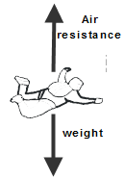  Air resistance = weight  Therefore resultant force = 0  Therefore acceleration = 0  Therefore speed is constant

I get ignored so much that sometimes I think I should just call myself ‘Air Resistance’.
2020 Question 6 [Ordinary Level]
A block weighs 400 N. A crane lifts the block so that it moves upwards with constant velocity.
- Use Newton’s first law of motion to find the force that the crane puts on the block.
- Use Newton’s third law to explain how a rocket takes off.

Part (i) | If it’s going at constant velocity then the net force acting on it must be zero so if the weight of the block is 400 N then the force upwards must also be 400 N.
Part (ii) | The rocket exerts a downwards force on the gas therefore the gas exerts an equal and opposite force upwards on the rocket, causing the rocket to accelerate upwards.

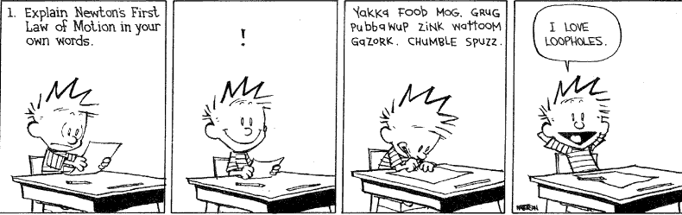

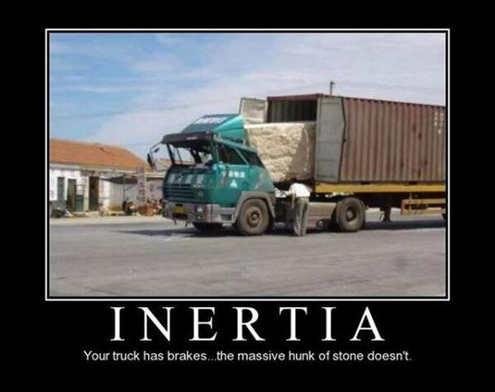

To Show that F = ma is a special case of Newton’s second law

Remember Newton’s Second Law: Force is proportional to the rate of change of momentum

This can be written mathematically as follows: $F∝\frac{mv-mu}{t}$

Now we take out m as a common factor: $F∝m(\frac{v-u}{t})$

But $\frac{v-u}{t}$ is simply acceleration, so we can replace it by the letter a to give $F∝ma$

Now we can replace our proportional sign with = and a constant k. to give: F = k (ma)

But k = 1 (from our definition of the newton).

Therefore F = ma

Impulse

Change in momentum is also known as ‘impulse’: Impulse = mv – mu

Let’s look again at the derivation above:
$F∝\frac{mv-mu}{t}$ $F=k\frac{mv-mu}{t}$

but k = 1 as above $F=\frac{mv-mu}{t}$ or $F=\frac{∆p}{∆t}$

Impulse = Ft = (mv – mu)

This relationship is important when trying to improve performance in ball games; if you want to make a ball go faster (change its momentum) then you need to either increase the force applied (not always easy to do) or else increase the time for which the force is applied (golf players and tennis players are often instructed to ‘follow through’).

2013 Question 6 [Ordinary Level]
A truck of mass 5000 kg is moving with a velocity 10 m s⁻¹ when it collides with a stationary car with a mass of 1000 kg. The truck and the car then move off together.
- Calculate the momentum of the truck and the car before the collision.
- What is the momentum of the combined vehicles after the collision?
- Calculate the velocity of the combined vehicles after the collision.
- What is the momentum of the truck after the collision?
- If the collision between the truck and the car takes 0.3 seconds, calculate the force exerted by the truck on the car.
Part (i) | Only the truck is moving so the only velocity is associated with the truck:  5000 × 10 = 50000 kg ms⁻¹
Part (ii) | Total momentum is the same before and after the interaction, so momentum after collision also is 50000 kg m s⁻¹
Part (iii) | Total momentum afterwards = 50000 kg ms⁻¹  Total mass afterwards = 5000 + 1000 = 6000 kg  50000 = 6000 × v  v = 50000 ÷ 6000 = 8.3 m s⁻¹
Part (iv) | Momentum of the truck after the collision = (mv) = (5000 × 8 .3) = 41500 kg m s⁻¹
Part (v) | Momentum before (mu) = 50000 kg ms⁻¹  Momentum after (mv) = 41500 kg ms⁻¹  Impulse = Ft = (mv – mu) Force = [(mu – mv)÷time]  Force = [(50000 – 41500) ÷ 0.3] = 27800 N

2013 Question 6 [Ordinary Level]  When a truck hits the back of the car the car driver’s airbag inflates. The airbag deflates when it is hit by the driver’s head. Explain why the airbag reduces the risk of injury to the driver. | From Newton’s second law of motion: Force is proportional to the rate of change of momentum.  $Ft=mv-mu$  u = initial velocity at the time of contact and v = final velocity = 0 and so all terms on the right hand side are fixed so the total on the right hand side is fixed while both terms on the left depend on whether or not there is an airbag.  If the time (from first contact to head coming to a stop) increases then the force will be reduced. This is the force that the head exerts on the bag and (from Newton III) it will also be the force that the bag exerts on the head, reducing the pain and risk of injury.
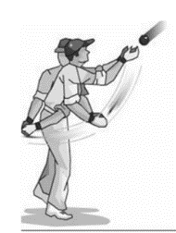  2020 Question 6 [Higher level]  A cricket player moves her hands away from the motion of the ball as she catches it.  Use Newton’s laws of motion to explain why she moves her hands away from the motion of the ball. | See previous answer.  If the time (from first contact to ball stopping) increases then the force will be reduced. This is the force that the hand exerts on the ball and (from Newton III) it will also be the force that the ball exerts on the hand, reducing the pain and so making it easier to hold on to the ball.
2019 Question 11 [second half]  A ball of mass 110 g is travelling at a speed of 4 m s^{–1}. It rebounds from a wall and travels in the opposite direction at the same speed. The ball was in contact with the wall for 0.2 seconds.  Use Newton’s laws of motion to calculate the force exerted by the wall on the ball. | m = 0.11 kg, u = 4 m s^{–1}, v = - 4 m s^{–1}, t = 0.2 s  $Ft=mv-mu$  $F(0.2)=(0.11)(4)-0.11(-4)$  F = 4.4 N
2014 Question 6 [Higher level]  A force of 5.3 kN is applied to a golf ball by a club.  The mass of the ball is 45 g and the ball and club are in contact for 0.54 ms.  Calculate the speed of the ball as it leaves the club. | F = 5300 N, m = 0.054 kg, u = 0, t = 0.54 × 10⁻³ s  $F=\frac{mv-mu}{t}$ $5300=\frac{\left(0.045\right)v-(0.045)(0)}{{0.54 ×10}^{-3}}$  v = 63.6 m s^{–1}
2008 Question 11 [Higher level]  A force of 9 kN is applied to a golf ball by a golf club.  The ball and club are in contact for 0.6 ms. Using Newton’s laws of motion, calculate the change in momentum of the ball. | F = 9000 N, t = 0.6 × 10⁻³ s  Impulse = change in momentum = Ft = (mv – mu)  So to calculate change in momentum we just need to calculate Ft  Ft = (9 × 10³)( 0.6 × 10⁻³) = 5.4 kg m s⁻¹

Newton’s laws of motion and the physics of concussions

$$F=\frac{mv-mu}{t}$$
Fun activity
Get two students to hold up a large sheet between them (an old bed-sheet will do fine). Throw raw eggs at it (one at a time) as hard as you can. The eggs will never break because the sheet deforms on impact, increasing the impact time, therefore the rate of change of change of momentum is less, resulting in a reduced force acting on the sheet (from Newton’s second law above) and an equal and opposite reduced force acting on the egg (from Newton’s third law).

Consider a rugby player (ROG) involved in a head-on collision with another player (BOD).
All of ROG’s head (skull and contents) is moving forward at high speed at the moment of collision. When ROG’s skull comes in contact with BOD’s skull it comes to a rapid stop. However his brain keeps moving (from Newton’s First Law of motion) until it collides with the inside of his skull. At the moment of impact the brain exerts a force on the skull and from Newton’s Third Law the skull exerts an equal force on the brain. Newton’s Second Law then tell us that the size of this force is determined by the rate of change of momentum; this will reduce if the initial speed (speed on impact) is reduces or if the time (from initial momentum to final momentum) increases.

You should be able to show how the same analysis applies to all concussions, regareless of whether the cause of the concussion is a car crash, boxing or even heading a football.

How does a helmet help? First we need to consider the concept of relative velocity. If you’re driving a car at 30 km per hour and you crash into a car in front which is travelling at 20 km per hour then your relative speed at impact is just 10 km per hour and the damage caused to the front car will be much less than if you were travelling at 30 km per hour and the car in front was stationary.

Now let’s assume that both players are wearing helmets. ROG’s helmet comes in contact with BOD’s helmet but the inside of each helmet is made of foam so it takes longer for ROG’s skull to come to a stop. So now when ROG’s skull (which is still travelling at full speed at the moment of impact) collides with ROG’s skull their relative speeds are much less. Therefore the

However it will still slow down while ROG’s brain in continuing to move forward at full speed. How does this help?

Relationship between mass and weight

The weight of an object is a measure of the Earth’s gravitational force acting on it.

Because weight is a force, it follows that the unit of weight is also the newton.
Mathematically: weight = mass × gravitational field strength (where gravitational field strength is a measure of the strength of the Earth’s gravitational field at that point).
W = mg

The unit of gravitational field strength is N/kg or N kg⁻¹ (can you see why?).

Now it just so happens that the value of gravitational field strength is the same as the value for acceleration due to gravity (9.8 m s⁻² on the surface of the Earth).

- Last night I dreamed that I was weightless. I was like, 0mg !

- Why diet? Visit the moon and lose weight!

How many different types of forces are there?
Answer: Four
2003 Question 6 [Ordinary Level]
An astronaut has a mass of 120 kg. What is the weight of the astronaut on the surface of the moon where acceleration due to gravity is 1.6 m s^{–2}
- The astronaut throws a stone straight up from the surface of the moon with an initial speed of 25 m s^{–1}. Describe how the speed of the stone changes as it reaches its highest point.
- Calculate the highest point reached by the stone.
- Calculate how high the astronaut can throw the same stone with the same initial speed of 25 m s^{–1} when on the surface of the earth, where the acceleration due to gravity is 9.8 m s^{–2}.
- Why is the acceleration due to gravity on the moon less than the acceleration due to gravity on the earth?
Part (i)  m = 120 kg  g = 1.6 m s^{–2} |  | W = mg = (120)(1.6) = 192 N.
Part (ii) |  | It slows down as it rises until at the highest point its speed is 0.
Part (iii)  u = 25 m s^{–1}  v =0  g = 1.6 m s^{–2} |  | Note that at the highest point the velocity is 0.  v² = u² + 2as ⇒ 0 = (25)² + 2 (-1.6)s  ⇒ s = 195.3 m.
Part (iv)  u = 25 m s^{–1}  v =0  g = 9.8 m s^{–2} |  | v² = u² + 2as ⇒ 0 = (25)² + 2 (-9.8) s  ⇒ s = 31.9 m.
Part (v) |  | The earth has a greater mass than the moon.
2006 Question 6 [Ordinary Level]
- Define the term force and give the unit in which force is measured.
- Explain the term acceleration due to gravity, g.
- Use this data to show that the acceleration due to gravity on the surface of the moon is 1.6 m s^{–2}.
- The astronaut has a mass of 120 kg.
Calculate his weight on the surface of the moon.
- Why is the astronaut’s weight greater on earth than on the moon?
- Explain why the moon does not have an atmosphere.

Part (i) |  | A force is something which causes an acceleration.  The unit of force is the newton.
Part (ii) |  | It is the acceleration of an object which is in freefall due to the gravitational pull of the earth.
Part (iii)  s = 1.6 m  t = 1.4 s  u = 0. |  | s = ut + ½ at²  1.6 = 0 + ½ (a)(1.4)²  a = 1.6 m s⁻².
Part (iv) |  | W = mg ⇒ W = (120)(1.6) = 192 N.
Part (v) |  | Because acceleration due to gravity is greater on the earth (or because the mass of the earth is greater than the mass of the moon).
Part (vi) |  | Because the gravitational force is less on the moon.
2012 Question 6 [Ordinary Level]
- A spacecraft has a mass 800 kg and is on the surface of the moon where the acceleration due to gravity is 1.6 m s⁻².
Compare the weight of the spacecraft on the surface of the moon with its weight on earth, where the acceleration due to gravity is 9.8 m s^{–2}.
- The module of the spacecraft has a mass of 600 kg and is launched vertically from the surface of the moon with its engine exerting an upward force of 2000 N.
Draw a diagram showing the forces acting on the module at lift-off.
- What is the resultant force on the module?
- Calculate the acceleration of the module during lift-off.
- Calculate the velocity of the module, 20 seconds after lift-off.
- Would the engine of the module be able to lift it off the earth’s surface? Justify your answer in terms of the forces acting on the module.
- Why is the acceleration due to gravity on the moon less than the acceleration due to gravity on earth?
- Suggest a reason why the module of the spacecraft when launched from the moon does not need a streamlined shape like those that are launched from earth.

Part (i) | Weight on moon = mg_{m}= (800)(1.6) = 1280 N  Weight on earth = mg_{e} = (800)(9.8) = 7840 N  So the spacecraft is (7840 ÷ 1280) = 6.1 times heavier on the earth than on the moon.
Part (ii) | 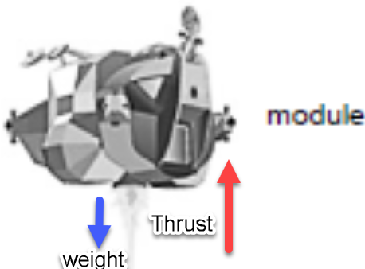  Weight acting down, thrust acting up. Note the arrow for Thrust has got to be longer than the arrow for weight.
Part (iii) | F_{net} = (F_{big} – F_{small}) = (Thrust - weight)  Thrust = 2000 N  Weight on the moon = mg = (600)(1.6) = 320 N  F_{net} = [2000 - 320] = 1040 N
Part (iv) | F_{net} = 1040 N m = 600 kg  F_{net} =ma ⇒ 1040 = (600)(a)  ⇒ a = 1.73 m s⁻²
Part (v)  u = 0,  a = 1.73 m s⁻²,  t = 20 s | v = u + at  v = 0 + (1.73)(20) = 34.6 m s⁻¹
Part (vi) | No. The force of gravity on the earth is 5880 N (600 × 9.8) and the upward thrust of the spacecraft is only 2000 N.
Part (vii) | Because the mass of the moon is less than the mass of the earth
Part (viii) | There is no atmosphere on the moon so no air resistance / drag / friction

Common student-errors when doing exam questions on Mechanics
Question
How did the student measure the weight of the metre stick?

Answer: Newton balance
Don’t say “electronic balance” as the default setting on electronic balances is to calculate mass in grams.

Don’t use the word ‘gravity’ on its own. Use ‘gravitational force’ if talking about the force of gravity.


https://www.newscientist.com/article/2267304-tom-gauld-has-a-heart-to-heart-with-dark-matter/

May the mass times acceleration be with you.

It’s not rocket science. Oh wait. Yes it is.

Sir Isaac Newton was not a fan of atheism
Atheism is so senseless & odious to mankind that it never had many professors. Can it be by accident that all birds beasts & men have their right side & left side alike shaped (except in their bowels) & just two eyes & no more on either side the face & just two ears on either side the head & a nose with two holes & no more between the eyes & one mouth under the nose & either two fore leggs or two wings or two arms on the sholders & two leggs on the hipps one on either side & no more? Whence arises this uniformity in all their outward shapes but from the counsel & contrivance of an Author? Whence is it that the eyes of all sorts of living creatures are transparent to the very bottom & the only transparent members in the body, having on the outside an hard transparent skin, & within transparent juyces with a crystalline Lens in the middle & a pupil before the Lens all of them so truly shaped & fitted for vision, that no Artist can mend them? Did blind chance know that there was light & what was its refraction & fit the eys of all creatures after the most curious manner to make use of it? These & such like considerations always have & ever will prevail with man kind to believe that there is a being who made all things & has all things in his power & who is therfore to be feared.
-- as mentioned in 'A short Schem of the true Religion'

Simple questions that don’t have simple answers
Hold out a page from a newspapers and get a friend to drop a golf ball on it from just above– it doesn’t tear. Now drop it from a greater height – it does tear. Why? Because the force is greater. Why is the force greater? Because the ball came from a greater height so had a greater acceleration, and from F = ma, if acceleration is greater then so is the force.
What is wrong with this explanation and what is the correct explanation?

SLOP

Define force. | A force is anything which can cause an object to accelerate.
Define the newton, the unit of force. | A force of 1 N gives a mass of 1 kg an acceleration of 1 m s⁻².
State Newton’s first law of motion. | An object stays at rest or moves with constant velocity unless an external force acts on it.
A spacecraft carrying astronauts is on a straight line flight from the earth to the moon and after a while its engines are turned off.  Explain why the spacecraft continues on its journey to the moon, even though the engines are turned off. | There are no external forces acting on the spacecraft so from Newton’s 1st law of motion the object will maintain its velocity.
State Newton’s second law of motion. | the rate of change of an object’s momentum is directly proportional to the force which caused it, and takes place in the direction of the force.
State Newton’s third law of motion. | Every object will remain in a state of rest or travelling with a constant velocity unless an external force acts on it.
The cheetah is one of the fastest land animals. Calculate the resultant force acting on the cheetah while it is accelerating at a rate of 7 m s⁻². The mass of the cheetah is 150 kg. | F = ma ⇒ F = 150 × 7 = 1050 N
Name two forces acting on a cheetah while it is running. | Weight, friction, air resistance.
An astronaut of mass 120 kg is on the surface of the moon, where the acceleration due to gravity is 1.6 m s^{–2}. What is the weight of the astronaut on the surface of the moon? | W = mg = 120 × 1.6 = 192 N.
Why is the astronaut’s weight greater on earth than on the moon? | Because acceleration due to gravity is greater on the earth (because the mass of the earth is greater than the mass of the moon).
The earth is surrounded by a layer of air, called its atmosphere. Explain why the moon does not have an atmosphere. | Because gravity is less on the moon.
A lunar buggy designed to travel on the surface of the moon (where acceleration due to gravity is1.6 m s⁻²) had a mass of 2000 kg when built on the earth.  What is the weight of the buggy on earth? | W = mg = 2000 × 9.8 = 19600 N
What is the mass of the buggy on the moon? | 2000 kg
What is the weight of the buggy on the moon? | W = mg = 2000 × 1.6 = 3200 N
A powerful rocket is required to leave the surface of the earth.  A less powerful rocket is required to leave the surface of the moon. Explain why. | The force of gravity is less on moon so less force is needed to escape.
Using Newton’s first law of motion, explain what would happen to the passengers if they were not wearing seatbelts while the aircraft was landing. | They would continue to move at the greater initial velocity and so would be ‘thrown’ forward.
Use a diagram to show the forces acting on a skydiver and explain why he reaches a constant speed. | Weight acting down.  Air resistance / friction / buoyancy acting up.  He will move at constant speed once air resistance = weight, therefore resultant force = 0  Therefore acceleration = 0
What is friction? | Friction is a force which opposes the relative motion between two objects.
Momentum
Define momentum. | Momentum is the product of mass and velocity.
Give the unit of momentum. | The unit of momentum is the kg m s⁻¹
State the principle of conservation of momentum. | The principle of conservation of momentum states that in any collision between two objects, the total momentum before impact equals total momentum after impact, provided no external forces act on the system.
Use Newton’s second law to establish the relationship: force = mass × acceleration. | From Newton II: Force is proportional to the rate of change of momentum  F ∝ (mv – mu)/t ⇒F ∝ m(v-u)/t  ⇒F ∝ ma ⇒F = k (ma) ⇒F = ma
Use the principle of conservation of momentum to explain why a rocket rises. | The gas moves down (with a momentum) causing the rocket to move up (in the opposite direction with an equal momentum)
What is the momentum of an object with a mass of 5 kg travelling at 10 m s⁻¹? | Momentum = mass × velocity  = 5 × 10 = 50 kg m s⁻¹.
A spacecraft is approaching a space station at a constant speed. The spacecraft must slow for it to lock onto the space station. In what direction should the gas be expelled? | Forward (toward the space station).  As the gas is expelled in one direction the rocket moves in the other direction.
A force of 9 kN is applied to a golf ball by a golf club. The ball and club are in contact for 0.6 ms.  Using Newton’s laws of motion, calculate the change in momentum of the ball. | F ∝ (mv – mu)/t  F = (mv – mu)/t  (mv – mu) = F × t = (9 × 10³)( 0.6 × 10⁻³)  = 5.4 kg m s⁻¹.

Comment exam mistakes
Can you spot the mistake?

 | Incorrect answer | Incorrect answer | Incorrect answer
Define the newton | The unit of force | The force required to give a mass of 1 kg a velocity of 1 m s⁻¹. | The force required to give a mass of 1 kg an acceleration of 1 m s⁻¹
Newton’s first law | An object will move at constant speed unless an external force acts on it.

The science of learning quiz: Part 8

      - You’ve covered a new topic in maths and have been given a page of similar questions to do for practice in your own time. How many should you do?

      - I’ve been trying to solve this maths question for the past half-hour but I just can’t get the right answer. How long more should I spend at it before giving up and just looking at the solution?

      - Is it okay to watch YouTube as a form of study?


Many words in Physics mean something completely different in the everyday world.
How many can you think of?

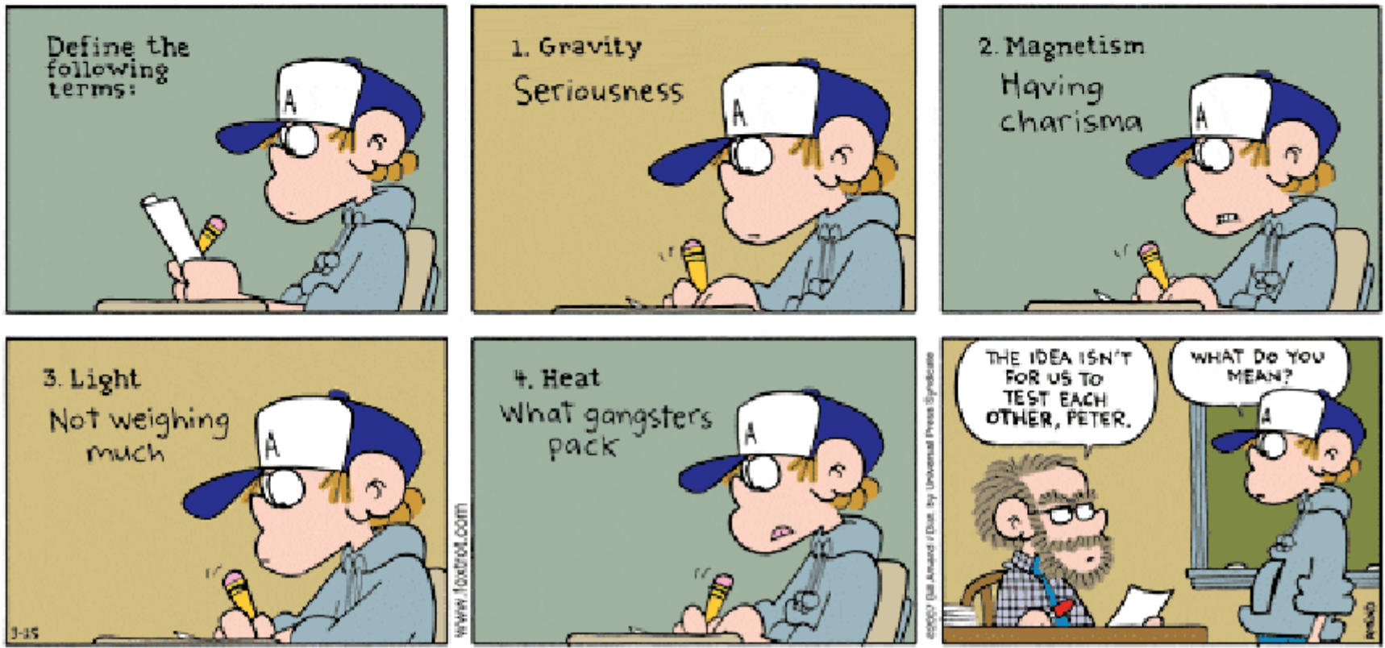

Answers

      - You’ve covered a new topic in maths and have been given a page of similar questions to do for practice in your own time. How many should you do?
Keep doing them until they no longer prove difficult; then rather than doing more of the same type of questions you should instead go back and try questions from a previous chapter which you may have partly forgotten how to do.
Why?
We know that if we want to learn a motor skill like dribbling a football then we need to practise as much as possible, and we assume the same goes for mental skills, but research tells us otherwise. If you are working through a set of problems without even having to think about them then the learning is minimal (remember ‘desirable difficulties’?). So instead spend your time retrieving solutions to earlier questions. For example rather than doing questions 1 – 4, do questions 1 – 3 and then do a question from the previous day and/or week.
But now you need to make sure that you come back to question 4 on the following day and maybe question 5 the following week.

      - I’ve been trying to solve this maths question for the past half-hour but I just can’t get the right answer. How long more should I spend at it before giving up and just looking at the solution?
It somehow seems obvious that you should stick at a problem until you manage to work it out for yourself. Strange though it may seem, this isn’t always the smartest option. Take a minute to think about it. It would only seem fair that the reward for working it out yourself is that the brain will remember it from now on - but your brain doesn’t work on the principles of fairness. Why should it pay more attention to a problem just because you worked it out yourself instead of listening to somebody else explain it to you? And yes of course there is some benefit to working it out yourself; you are more likely to be involved in elaborative interrogation while doing so, but you will have crossed this threshold once you’ve spent five minutes or so on it. The rest of the time could be better spent looking at the worked solution and then either trying a related question to make sure you understand it, or doing a different question (or subject) completely.

      - Is it okay to watch YouTube as a form of study?
Short answer - it depends . . .
What are you using it for? If it is to try and understand a concept that you otherwise can’t get your head around then go for it. Just be wary of one or two issues:
- Don’t allow yourself to get sidetracked and end up using valuable study time browsing through videos which are of limited use.
- Remember that this is merely an initial step. No information will be stored in your long-term memory until you first think about it some meaningful way and then you need to practice retrieving it using any of the methods discussed elsewhere in this booklet.

MECHANICS I EXAM QUESTIONS 2002 – 2022
Ordinary and Higher level

Velocity and acceleration
[ordinary level]

2020 Question 12 (a) [Ordinary Level]
A bus travels 30 km in 28 minutes at a constant speed.
- Convert 30 km into metres.
- Convert 28 minutes into seconds.
- Use your answers to (i) and (ii) to calculate the speed of the bus in m s^{–1}.

The driver applies the brakes and brings the bus to a stop in 30 seconds.
- Sketch a velocity‐time graph of the bus’s journey.
- What is the difference between speed and velocity?

2018 Question 12 (a) [Ordinary Level]
- Define velocity.
- Define acceleration.
- A train left a station and accelerated from rest at 0.4 m s⁻² to reach its top speed of 55 m s⁻¹.
The train then travelled for 300 seconds at this speed.
- Calculate how long it took the train to reach its top speed.
- How far did the train travel while at its top speed?
- Draw a velocity‐time graph of the train’s journey.

2017 Question 12 (a) [Ordinary Level]
- Define velocity and friction.
A car started from rest and accelerated at 0.4 m s⁻² to reach a top speed of 28 m s⁻¹.
It maintained this speed for 200 seconds.
When the car approached its destination, the driver applied the brakes uniformly to bring it to a stop in 30 s.
- Draw a diagram indicating the main forces acting on the car when it was accelerating.
- Calculate how long it took the car to reach its top speed.
- Sketch the velocity-time graph for the journey.

2004 Question 6 [Ordinary Level]
- Define velocity.
- Define acceleration.
- Describe an experiment to measure the velocity of a moving object.
- A cheetah can go from rest up to a velocity of 28 m s⁻¹ in just 4 seconds and stay running at this velocity for a further 10 seconds.
Sketch a velocity−time graph to show the variation of velocity with time for the cheetah during these 14 seconds.
- Calculate the acceleration of the cheetah during the first 4 seconds.
- Calculate the resultant force acting on the cheetah while it is accelerating.
The mass of the cheetah is 150 kg.
- Name two forces acting on the cheetah while it is running.

2008 Question 12 (a) [Ordinary Level]
- Define velocity.
- Define acceleration.
- A speedboat starts from rest and reaches a velocity of 20 m s⁻¹ in 10 seconds.
It continues at this velocity for a further 5 seconds.
The speedboat then comes to a stop in the next 4 seconds.
Draw a velocity-time graph to show the variation of velocity of the boat during its journey.
- Use your graph to estimate the velocity of the speedboat after 6 seconds.
- Calculate the acceleration of the boat during the first 10 seconds.
- What was the distance travelled by the boat when it was moving at a constant velocity?

2010 Question 12 (a) [Ordinary Level]
- A cyclist on a bike has a combined mass of 120 kg.
The cyclist starts from rest and by pedalling applies a net force of 60 N to move the bike along a horizontal road.
Calculate the acceleration of the cyclist.
- Calculate the maximum velocity of the cyclist after 15 seconds.
- Calculate the distance travelled by the cyclist during the first 15 seconds.
- The cyclist stops peddling after 15 seconds and continues to freewheel for a further 80 m before coming to a stop. Why does the bike stop?
- Calculate the time taken for the cyclist to travel the final 80 m.

2014 Question 12 (a) [Ordinary Level]
- Explain the distinction between speed and velocity.

A bus leaves a bus stop and accelerates from rest at 0.5 m s⁻² to reach a speed of 15 m s⁻¹.
It then maintains this speed for 100 seconds. When it approaches the next stop, the driver applies the brakes uniformly to bring the bus to a stop in 20 seconds.
- Calculate the time it took the bus to reach its top speed.
- Calculate the distance it travelled while at its top speed.
- Calculate the acceleration required to bring the bus to a stop.
- Sketch a velocity-time graph of the bus journey.

Velocity and acceleration
[higher level]

2010 Question 12 (a) [Higher Level]

The graph in Figure 2 represents the motion of a cyclist on a journey.
Using the graph, calculate the distance travelled by the cyclist and the average speed for the journey.

Forces: Ordinary level

2002 Question 6 [Ordinary Level]
- Define (i) velocity, (ii) acceleration.
- Copy and complete the following statement of Newton’s first law of motion.
“An object stays at rest or moves with constant velocity (i.e. it does not accelerate) unless………………..”
The diagram shows the forces acting on an aircraft travelling horizontally at a constant speed through the air.

L is the upward force acting on the aircraft.
W is the weight of the aircraft.
T is the force due to the engines.
R is the force due to air resistance.

- What happens to the aircraft when the force L is greater than the weight of the aircraft?
- What happens to the aircraft when the force T is greater than the force R?
- The force T exerted by the engines is 20 000 N.
Calculate the work done by the engines while the aircraft travels a distance of 500 km.
- The aircraft was travelling at a speed of 60 m s⁻¹ when it landed on the runway. It took two minutes to stop. Calculate the acceleration of the aircraft while coming to a stop.
- The aircraft had a mass of 50 000 kg. What was the force required to stop the aircraft?
- Using Newton’s first law of motion, explain what would happen to the passengers if they were not wearing seatbelts while the aircraft was landing.

2022 Question 7 [Ordinary Level]
A train of mass 420000 kg started from rest and accelerated to a velocity of 25 m s^{–1} in a time of 6 minutes.

- What is meant by velocity?
- Convert 6 minutes into seconds.
- Calculate the acceleration of the train. Include units in your answer.
- Calculate the force required to accelerate the train.
- Calculate the distance the train travelled in 6 minutes.

The train then maintained this speed of 25 m s^{–1} for a further 15 minutes.
- Calculate the distance the train travelled during this 15 minute interval.
- Draw a labelled diagram to show the forces acting on the train while it is moving with constant speed.
- An object may have a constant speed but not a constant velocity. Explain why.
- Draw a speed‐time graph for the train during the first 21 minutes of its journey.

Forces: Higher level

2007 Question 12 (a) [Higher Level]
- What is friction?
- A car of mass 750 kg is travelling east on a level road. Its engine exerts a constant force of 2.0 kN causing the car to accelerate at 1.2 m s^{–2} until it reaches a speed of 25 m s^{–1}.
- Calculate (i) the net force, (ii) the force of friction, acting on the car.
- If the engine is then turned off, calculate how far the car will travel before coming to rest.

2003 Question 12 (a) [Higher Level]
- State Newton’s second law of motion.
- A skydiver falls from an aircraft that is flying horizontally.
He reaches a constant speed of 50 m s^{–1} after falling through a height of 1500 m.
Calculate the average vertical acceleration of the skydiver.
- If the mass of the skydiver is 90 kg, what is the magnitude and direction of the average resultant force acting on him?
- Use a diagram to show the forces acting on the skydiver and explain why he reaches a constant speed.

Momentum: Ordinary level
2013 Question 6 [Ordinary Level]
Define momentum,
Define force.
State the principle of conservation of momentum.
Explain how the principle of conservation of momentum applies in the case of a jet engine moving an aircraft.

A truck of mass 5000 kg is moving with a velocity 10 m s⁻¹ when it collides with a stationary car with a mass of 1000 kg. The truck and the car then move off together.

- Calculate the momentum of the truck and the car before the collision.
- What is the momentum of the combined vehicles after the collision?
- Calculate the velocity of the combined vehicles after the collision.
- What is the momentum of the truck after the collision?
- If the collision between the truck and the car takes 0.3 seconds, calculate the force exerted by the truck on the car.
- When the truck hits the back of the car the driver’s airbag inflates. The airbag deflates when it is hit by the driver’s head. Explain why the airbag reduces the risk of injury to the driver.

2007 Question 12 (a) [Ordinary Level]
- State the principle of conservation of momentum.
- A rocket is launched by expelling gas from its engines.
Use the principle of conservation of momentum to explain why a rocket rises.

- The diagram shows two shopping trolleys each of mass 12 kg on a smooth level floor.
Trolley A moving at 3.5 m s⁻¹ strikes trolley B, which is at rest.
After the collision both trolleys move together in the same direction.
Calculate the initial momentum of trolley A
- Calculate the common velocity of the trolleys after the collision.

2004 Question 12 (a) [Ordinary Level]
- Define momentum. Give the unit of momentum.
- State the principle of conservation of momentum.
- The diagram shows a child stepping out of a boat onto a pier.
The child has a mass of 40 kg and steps out with an initial velocity of 2 m s⁻¹ towards the pier.
The boat, which was initially at rest, has a mass of 50 kg.
Calculate the initial velocity of the boat immediately after the child steps out.

2023 Question 14 (a) [Ordinary level]
A train has a mass of 180 000 kg and is travelling at a speed of 4 m s^{–1}.
- Calculate the momentum of the train. Include units in your answer.
The train then joins together with a carriage of mass 85 000 kg which is at rest.
- What is the momentum of the carriage before the coupling?
- Explain your answer.
- Calculate the initial velocity of the train after it joins with the carriage.

- The train then accelerates to a speed of 22 m s^{–1}. It maintains this speed for 8 minutes.
Calculate the distance travelled by the train over the 8 minutes.

Momentum: Higher level

2002 Question 12 (a) [Higher Level]
- State the principle of conservation of momentum.
- A spacecraft of mass 50 000 kg is approaching a space station at a constant speed of 2 m s⁻¹. The spacecraft must slow to a speed of 0.5 m s⁻¹ for it to lock onto the space station.
Calculate the mass of gas that the spacecraft must expel at a speed 50 m s⁻¹ for the spacecraft to lock onto the space station. (The change in mass of the spacecraft may be ignored.)
- In what direction should the gas be expelled?
- Explain how the principle of conservation of momentum is applied to changing the direction in which a spacecraft is travelling.

SOLUTIONS TO ORDINARY LEVEL EXAM QUESTIONS 2002 – 2023

2002 Question 6
- Define velocity.
Velocity is the rate of change of displacement with respect to time.
- Define acceleration.
Acceleration is the rate of change of velocity with respect to time
- “An object stays at rest or moves with constant velocity (i.e. it does not accelerate) unless an external force acts on it”.
- What happens to the aircraft when the force L is greater than the weight of the aircraft?
It accelerates upwards.
- What happens to the aircraft when the force T is greater than the force R?
It accelerates forward.
- Calculate the work done by the engines while the aircraft travels a distance of 500 km.
Work = Force × displacement ⇒ 20000 × 500 000 = 1 × 10¹⁰ J
- Calculate the acceleration of the aircraft while coming to a stop.
v = u + at ⇒ 0 = 60 + a (120) ⇒ a = - 0.5 m s⁻²
- The aircraft had a mass of 50 000 kg. What was the force required to stop the aircraft?
F = ma ⇒ F = 50 000 × 0.5 = 25 000 N.
- Using Newton’s first law of motion, explain what would happen to the passengers if they were not wearing seatbelts while the aircraft was landing.
They would continue to move at the greater initial velocity and so would be ‘thrown’ forward.

2003 Question 6
- “Any two point masses attract each other with a force which is proportional to the product of their masses and inversely proportional to the square of the distance between them.”
- What is meant by the term acceleration due to gravity?
It is the acceleration which objects in freefall experience due to the pull of the earth.
- What is the weight of the astronaut on the surface of the moon?
W = mg = 120 × 1.6 = 192 N.
- The astronaut throws a stone straight up from the surface of the moon with an initial speed of 25 m s^{–1}. Describe how the speed of the stone changes as it reaches its highest point.
It slows down as it rises until at the highest point its speed is 0.
- Calculate the highest point reached by the stone.
v² = u² + 2as ⇒ 0 = (25)² + 2 (-1.6)s ⇒ s = 195.3 m.
- Calculate how high the astronaut can throw the same stone with the same initial speed of 25 m s^{–1} when on the surface of the earth, where the acceleration due to gravity is 9.8 m s^{–2}.
v² = u² + 2as ⇒ 0 = (25)² + 2 (-9.8) s ⇒ s = 31.9 m.
- Why is the acceleration due to gravity on the moon less than the acceleration due to gravity on the earth?
The earth has a greater mass than the moon.

2004 Question 6
- Define velocity. Velocity is the rate of change of displacement with respect to time.
- Define acceleration.
Acceleration is the rate of change of velocity with respect to time.
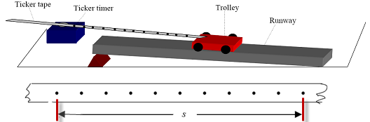
- Describe an experiment to measure the velocity of a moving object.
We measured the distance between 11 dots and the time was the time for 10 intervals, where each interval was 1 50th of a second.
We then used the formula velocity = distance/time to calculate the velocity.
- Sketch a velocity−time graph to show the variation of velocity with time for the cheetah during these 14 seconds.
See graph
- Calculate the acceleration of the cheetah during the first 4 seconds.
v = u + at ⇒ 28 = 0 + a(4) ⇒ a = 7 m s⁻²
- Calculate the resultant force acting on the cheetah while it is accelerating. The mass of the cheetah is 150 kg.
F = ma ⇒ F = 150 × 7 = 1050 N
- Name two forces acting on the cheetah while it is running.
Gravity (or weight), friction, air resistance.

2004 Question 12 (a)
- Define momentum. Give the unit of momentum.
Momentum = mass × velocity.
The unit of momentum is the kg m s⁻¹
- State the principle of conservation of momentum.
The Principle of Conservation of Momentum states that in any collision between two objects, the total momentum before impact equals total momentum after impact, provided no external forces act on the system.
- Calculate the initial velocity of the boat immediately after the child steps out.
m₁u₁ + m₂u₂ = m₁v₁ + m₂v₂ ⇒ 0 = (40)(2) + (50)x
⇒ x = - 1.6 m s⁻¹
2006 Question 6
- Define the term force and give the unit in which force is measured.
A force is something which causes an acceleration.
The unit of force is the newton.
- Force is a vector quantity. Explain what this means.
A vector is a quantity which has magnitude and direction.
- Give two factors which affect the size of the gravitational force between two bodies.
The mass of the objects and the distance between them.
- Explain the term acceleration due to gravity, g.
It is the acceleration of an object which is in freefall due to the attraction of the earth.
- Use this data to show that the acceleration due to gravity on the surface of the moon is 1.6 m s^{–2}.
s = 1.6 m, t = 1.4 s, u = 0. Substitute into the equation s = ut + ½ at² to get a = 1.6 m s⁻².
- The astronaut has a mass of 120 kg. Calculate his weight on the surface of the moon.
w = mg ⇒ w = (120)(1.6) = 192 N.
- Why is the astronaut’s weight greater on earth than on the moon?
Because acceleration due to gravity is greater on the earth (or because the mass of the earth is greater than the mass of the moon).
- Explain why the moon does not have an atmosphere.
Because gravity is less on the moon.

2007 Question 12 (a)
- State the principle of conservation of momentum.
The principle of conservation of momentum states that in any collision between two objects, the total momentum before impact equals total momentum after impact provided no external forces act on the system.
- Use the principle of conservation of momentum to explain why a rocket rises.
The gas moves down (with momentum) causing the rocket to move up (in the opposite direction with an equal momentum)
- Calculate the initial momentum of trolley A
mu = 12×3.5 = 42 kg m s⁻¹
- Calculate the common velocity of the trolleys after the collision.
Momentum before = Momentum after
Momentum before = 42, so momentum after = 42
42 = m₃v₃
⇒ v₃ = 42/m₃ ⇒ v = 42/24 = 1.75 m s⁻¹

2008 Question 12(a)
- Define velocity.
Velocity is the change in displacement with respect to time.
- Define acceleration.
Acceleration is the change in velocity with respect to time
- A speedboat starts from rest and reaches a velocity of 20 m s⁻¹ in 10 seconds.
It continues at this velocity for a further 5 seconds.
The speedboat then comes to a stop in the next 4 seconds.
Draw a velocity-time graph to show the variation of velocity of the boat during its journey.
- Use your graph to estimate the velocity of the speedboat after 6 seconds.
12 m s⁻¹.
- Calculate the acceleration of the boat during the first 10 seconds.
A = v/t = 20/10 = 2 m s⁻².
- What was the distance travelled by the boat when it was moving at a constant velocity?
v = s/t ⇒ s = vt = 20×5 = 100 m

2010 Question 12 (a)
- Calculate the acceleration of the cyclist
F = ma, a = 60/120
a = 0.5 m s^{–2}
- Calculate the maximum velocity of the cyclist after 15 seconds.
v = u + at
v = u + (0.5)(15) = 7.5 m s^{–1}
- Calculate the distance travelled by the cyclist during the first 15 seconds.
s = ut + ½ at² s = ut + ½ (0.5)(15)² = 56.25 m.
- The cyclist stops peddling after 15 seconds and continues to freewheel for a further 80 m before coming to a stop. Why does the bike stop?
Due to friction / air resistance.
- Calculate the time taken for the cyclist to travel the final 80 m?
v² = u² + 2as 0 = (7.5)² + 2a(80) a = - (7.5)²/(2)(80) a = - 0.35 m s^{–2}

Then use v = u + at 0 = 7.5 – (0.35)(t) t = -7.5/-0.35 = 21.43s

Alternatively we could just have used s = (u +v)t/2
80 = (7.5 + 0)t/2
t = 21.33 s

2012 Question 6
- What is meant by the term ‘acceleration due to gravity’?
Acceleration caused by the (gravitational pull of the) earth
- Compare the weight of the spacecraft on the surface of the moon with its weight on earth, where the acceleration due to gravity is 9.8 m s^{–2}.
Weight on moon = mg_{m}= (800)(1.6) = 1280 N
Weight on earth = mg_{e} = (800)(9.8) = 7840 N
So the spacecraft is (7840/1280) = 6.1 times heavier on the earth than on the moon.
- Draw a diagram showing the forces acting on the module at lift-off.
Weight acting down, thrust acting up.
- What is the resultant force on the module?
F_{net} = (F_{big} – F_{small}) = (F - mg_{m}) = [2000 - (600)(1.6)] = 1040 N
- Calculate the acceleration of the module during lift-off.
F_{net} =ma ⇒ 1040 = (600)(a) ⇒ a = 1.73 m s⁻²
- the velocity of the module, 20 seconds after lift-off.
(v = u + at ) i.e. v = 0 + (1.73)(20) = 34.6 m s⁻¹
- Would the engine of the module be able to lift it off the earth’s surface?
No. The force of gravity on the earth is 5880 N (600 × 9.8) and the upward thrust of the spacecraft is only 2000 N.
- Why is the acceleration due to gravity on the moon less than the acceleration due to gravity on earth?
Because the mass of the moon is less than the mass of the earth
- Suggest a reason why the module of the spacecraft when launched from the moon does not need a streamlined shape like those that are launched from earth.
There is no atmosphere on the moon so no air resistance / drag / friction

2013 Question 6
- Define momentum
Momentum is mass multiplied by velocity
- Define force
Force is that which can cause an object to accelerate.
- State the principle of conservation of momentum.
Total momentum before an interaction equals total momentum after an interaction, provided no external forces.
- Explain how the principle of conservation of momentum applies in the case of a jet engine moving an aircraft.
Backward momentum of the expelled gas equals the forward momentum of the aircraft.
- Calculate the momentum of the truck and the car before the collision.
Only the truck is moving so the only velocity is associated with the truck: 5000 × 10 = 50000 kg ms⁻¹
- What is the momentum of the combined vehicles after the collision?
50000 kg ms⁻¹
- Calculate the velocity of the combined vehicles after the collision.
50000 = m3v3 50000 = 6000 v3 v3 = 50000 ÷ 6000 = 8.3 m s⁻¹.
- What is the momentum of the truck after the collision?
(8.3 × 5000) = 41 500 kg m s⁻¹
- If the collision between the truck and the car takes 0.3 seconds, calculate the force exerted by the truck on the car.
Force equals rate of change of momentum = [(mu – mv)÷time] = [(50000 – 41500) ÷ 0.3] = 27.8 kN
- Explain why the airbag reduces the risk of injury to the driver.
The longer time reduced the force on the driver’s head.

2014 Question 12 (a)
- Explain the distinction between speed and velocity.
velocity is speed in a given direction // velocity is a vector // sound is a scalar
- Calculate the time it took the bus to reach its top speed.
v = u + at
t = (v-u)/a = (15 – 0 ) / 0.5 = 30 s
- Calculate the distance it travelled while at its top speed.
s= ut + ½ at² {but acceleration = 0}
s = (15)(100) = 1500 m
- Calculate the acceleration required to bring the bus to a stop.
a= (v – u ) / t = (0– 15 ) / 20 = – 0.75 m s ^{–2}
- Sketch a velocity-time graph of the bus journey.
see graph

2017 Question 12 (a)
- Define velocity and friction.
(i) Velocity is the rate of change of displacement // distance over time in a given direction
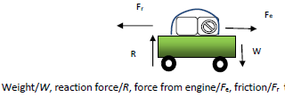
(ii) Friction is a force between 2 bodies in contact which opposes motion
- Draw a diagram indicating the main forces acting on the car when it was accelerating.
- Calculate how long it took the car to reach its top speed.
(v = u + at 28 = 0 + 0.4t t= $\frac{28}{0.4}=70 s$
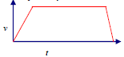
- Sketch the velocity-time graph for the journey.

2018 Question 12 (a)
- Define velocity.
velocity is the rate of change of displacement OR velocity = displacement divided by time
- Define acceleration.
Acceleration is the rate change in velocity OR acceleration = change in velocity divided by time taken.
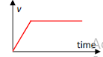
- Calculate how long it took the train to reach its top speed.
$t=\frac{v-u}{a}= \frac{55-0}{0.4}$ = 137.5 seconds
- How far did the train travel while at its top speed?
s = (speed)(time) = (300)(55) = 16500 m
- Draw a velocity‐time graph of the train’s journey.
See diagram; put in 55 m/s on the velocity axis and 137.5 seconds in the appropriate place on the time axis.

2020 Question 12 (a)
- Convert 30 km into metres.
30000 m
- Convert 28 minutes into seconds.
28 × 60 = 1680 s
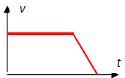
- Use your answers to (i) and (ii) to calculate the speed of the bus in m s^{–1}.
$v=\frac{s}{t}=\frac{30000}{1680}$ = 17.86 m s⁻¹
Sketch a velocity‐time graph of the bus’s journey.
See diagram, although it should have the velocity of 17.86 noted on the velocity axis.

2022 Question 7
- What is meant by velocity?
rate of change of displacement / speed in a given direction / s ÷ t
- Convert 6 minutes into seconds.
6 × 60 = 360 s
- Calculate the acceleration of the train. Include units in your answer.
25 ÷ 360 = 0.069 m s^{–2}
- Calculate the force required to accelerate the train.
F = ma = 420000 × 0.069 = 29166.7 N
- Calculate the distance the train travelled in 6 minutes.
s = 4500 m
- Calculate the distance the train travelled during this 15 minute interval.
25 × 15 × 60 = 22500 m
- Draw a labelled diagram to show the forces acting on the train while it is moving with constant speed.
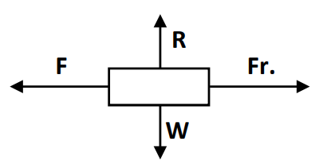
- An object may have a constant speed but not a constant velocity. Explain why.
it is changing direction
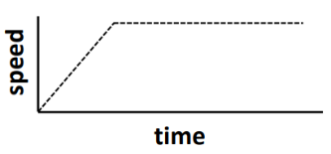
- Draw a speed‐time graph for the train during the first 21 minutes of its journey.

Why would we ever want to know about displacement? Answer 1: Lots of contexts in physics involve displacement rather than distance, we will come across some of these in the next chapter on acceleration so for now just shut up and get on with it. Answer 2: Conservation laws are the foundation stones upon which all of physics stands (but nobody tells you this), the most well-known of which is the conservation of energy and here we are (usually) only concerned with the beginning and end points (in order to establish the height an object rises or falls) and not the path taken. We will come across energy again later in the course.
S.I. stands for Système international, which is the system scientists use when recording measurements.
Note that if typing m s⁻¹ there should be a space between the m and the s⁻¹ (ms⁻¹ would imply a milli s⁻¹).
While there is a difference between speed and velocity in many contexts we can use either word – you will see these words used interchangeably throughout textbooks and exam questions.
Yes this does seem bizarre, but that’s how we roll here in the world of Physics. The concept of displacement exists because many of the physics equations which we use in the next chapter refer to displacement, and this in turn is because we are usually interested in the straight line distance between two points, not distance travelled, when solving problems (although if the distance travelled is in a straight line, then distance travelled will be equivalent to displacement).
The jerk and the jounce So if the rate of change of position with respect to time is velocity, and the rate of change of velocity with respect to time is acceleration, what about the rate of change of acceleration with respect to time? This is indeed ‘a thing’ (as you young people say). It is called the jerk, and before you ask, the next one is called the jounce. These are important considerations when one is building a roller-coaster, space shuttle or even delicate instruments. And yes the instrument for measuring jerks is called a jerkmeter.
We will show how to derive these equations later in this chapter
Why s for displacement? Answer 1: The concept of displacement comes from Galileo and he used the letter S, possibly from the Latin for distance, 'spatia'. Answer 2: s is short for "space covered".
Use the equations of motion to prove 1 = 2 Take two of the above formulae: v = u + at and s = ut + ½ at². Assume a particle begins from rest so both formulae reduce to v = at and s = ½ at². Cross-multiply to get a on its own on both sides: a = v/t and a = 2s/t². Equate both right hand sides: v/t = 2s/t². Multiply both sides by t: v = 2s/t. Substitute v for s/t on the right-hand side (because velocity equals distance divided by time) and you get v = 2v, or 1 = 2!!
Best demonstration of this that I know of is to drop a table tennis ball (or steel ball if you have one) and golf ball at the same time and watch them land together. Play this YouTube video at 0.25 speed to see it in action.
An invisible problem... What is 96% of the universe made of? Everything we see in the universe, from the ink in the full stop at the end of this sentence to mighty galaxies, is made up of ordinary matter. The problem is that this only accounts for 4% of the matter we know is out there. We know there must be a whole lot more because something out there is exerting an enormous gravitational pull on the galaxies themselves. The problem is that we can’t see it and we certainly can’t detect it – hence the term ‘dark matter’. Like so much in Physics, it would be nice if we had even an inkling into what the answer might be before civilisation implodes with the impact of Global Warming.
Newton Something most textbooks are uncomfortable with is the fact that the great Isaac Newton spent over 90 per cent of his time obsessing about alchemy and biblical prophecies. He spent 50 years (and 4,500 pages) trying to predict the precise date for the end of the world using a biblical code. He finally settled on 2060, which was found on a scrap of paper hidden in a trunk in 2003. Given our blind determination to put our own selfishness and desire for instant gratification ahead of any interest in our childrens’ welfare, it would seem that 2060 is a tad on the optimistic side. By the way, what he discovered with the other ten per cent of his time merely changed our view of both science and the universe. It wouldn’t be too great an exaggeration to say that his scientific research was almost an afterthought. One noted historian claimed that Newton was not the first great scientist; he was the last of the great mystics.
Demonstrating that air has mass Use a very large inflated balloon (a beachball is good) so that the mass of air inside is a couple of kg. If you hold the balloon up it feels weightless (and therefore massless) due to the upthrust from the displaced air outside the balloon, but throw the balloon so it hits the back of a suitable volunteer and they feel quite an impact due to the balloon’s momentum (mass × velocity).
This leads to a better definition for mass: mass = net force exerted on the object divided by its acceleration. Interestingly I have never seen the definition of mass being asked on an exam paper. Interestingly even Newton struggled to define mass. He claimed: “Quantity of matter is a measure of matter that arises from its density and volume jointly”’ but this is a circular and therefore unhelpful definition because density is defined as mass divided by volume. Sometimes it’s the simplest concepts that turn out to be the trickiest to nail down.
Calling an inanimate object a ‘body’ seems strange to us but it goes all the way back to Newton and possibly even farther back. I have never been able to establish why it became popular and it must seem even more peculiar to anyone learning English as a second language. I try to avoid it but you will see it used in exam questions so don’t let it throw you (because then you really would be a body being is projected through the air. Sorry).
This is an ibex (a species of wild goat) seeking salt deposits on the near vertical wall of a dam (google it).
But we could (and maybe even should) mention that the direction of the force is opposite to the direction in which the aircraft is moving. We usually don’t mention direction if it is obvious, but there were occasions when the marking scheme suggested that it should be included (usually for trickier questions where it wasn’t obvious).
Why do we make up a new quantity and then define it in terms of two other existing quantities? It just so happens that the product of mass and velocity is very important when analysing collisions. Whoever created the universe had a particular fondness for this quantity and made it one of the chief ingredients in one of the most fundamental principles in all of physics: the principle of conservation of momentum. And while we’re here, this is probably a good time to point out that this is a somewhat simplified version of the formula. In reality it should also include a term for electromagnetic radiation. But that’s for later on (in the topic entitled Particle Physics) when we look at particles appearing and disappearing into thin air. Hat tip also to a key concept in Quantum Physics known as Heisenberg’s uncertainty principle (yes, that Heisenberg) which states that states that there is limit to how much information we can know about specific pairs of physical properties such as position and momentum such that the more we know about a particle’s position the more uncertain we will be about its momentum is and vice versa. It’s also the foundation for the following popular physics joke: Heisenberg gets pulled over for speeding and the cop asks him "Do you know how fast you were going?".Heisenberg replies, "No, but I know exactly where I am!" I never claimed that it was a good joke.
In this case they both gained the same amount of momentum (where there was none before), but mathematically we describe one momentum as positive and the other as negative (because they are in opposite directions) therefore the total net momentum is still zero. Strange but true. This applies in many contexts (jet aircraft above, air escaping from a balloon, two skaters pushing against each other, man jumping off a dinghy or a wheely chair, water escaping from a hose, astronauts doing high-fives etc).
You need to know which law is Newton’s first law, which is his second etc. You can’t mix and match.
Modesty is not a word that comes to mind when describing Isaac Newton. “I now demonstrate the system of the world” he wrote when introducing the laws. But then I guess if anyone deserves to feel good about themselves it’s Newton. These laws (plus his law of gravitation which we’ll come to later) explain everything from the motion of a ball falling through the air to planets going around the sun. In fact one of the strangest ideas at the time is that the planets in the heavens follow the same laws of physics as those that apply down here on Earth. Add to this the idea that he introduced the idea that not all forces were necessarily contact forces.
Newton’s First Law Do you think you're sitting still right now? Well strap yourself in kid because right now you are on a planet orbiting a star at 30 km/s. That star is orbiting the center of a galaxy at 230 km/s. That galaxy is moving through the universe at 600 km/s. Since you started reading this, you have travelled at least 10000 km. My ten-year old daughter has just read this and has ordered me to turn off my laptop because I’ve just given her a headache
Newton’s Third Law This is sometimes explained by saying “For every action there is an equal and opposite reaction”; try to avoid that phrase as it can lead students to think that one event is followed by the other when in fact both forces are exerted on each other simultaneously. Secondly, we don’t recognise the term ‘action’ in physics (if we did we would have a unit for it). Place a book of weight 10 N on a table. The table 'reacts' with an equal and opposite force of 10 N. Put a smaller book of weight 5 N on top of the first book. The total weight is now 15 N so the reaction force is 15 N also. But how does the table know how much force to push back with? In fact what happens if the table gets its calculations wrong and pushes back with a force that is greater than 15 N? What’s going on here? So when you are pushing against a wall does this mean that the wall is pushing back? Well yes it does! So why don’t you end up moving backwards? Here’s a clue; what would happen if you tried it while wearing roller skates? And for that matter why is there an equal and opposite force between your hand and the wall? What is the origin of that force? It is very common for students (and teachers like me) to learn these off by heart without having a thorough understanding of each. Oscar Wilde’s refrain that ‘Man can believe the impossible, but man can never believe the improbable’ comes to mind whenever it comes time to teach this topic.
You can see that my Photoshop skills are coming along nicely.
The term ‘retardation’ was also used on occasion instead of deceleration but this has fortunately fallen out of favour in recent years.
Google videos of car crashes and car crash tests to get a better sense of Newton’s first law of motion. As a class activity build crumple zones on the front of trolleys to try and stop a nail impaling a plasticine man.
Raindrops also experience terminal velocity. This also partly explains why clouds (which, being composed of water droplets, and therefore being heavier than air, should fall) actually remain in the sky. The tiny droplets do accelerate but reach terminal velocity very quickly. In their case terminal velocity is 0.75 cm sec⁻¹. In the absence of any other forces they would continue at this pace but because these forces are so small they get swamped by the larger forces associated with thermals or the wind, and so simply end up being buffeted about. However if conditions are such that the droplets are allowed to increase in size considerably then the downward force of gravity has a greater affect, and the drops fall as rain.
This comes from how we define the newton: a mass of 1 kg experiencing a force of 1 N will accelerate at 1 m s⁻². If k was anything other than 1 then if F = 1 N and m = 1 kg it wouldn’t give us an acceleration of 1 m s⁻². Newton’s lesser known Fourth Law of Motion: A student in bed will remain in bed unless acted upon by a large enough panic. Newton originally wrote these in his famous book Principia. The convention at the time was to write learned books in Latin. Because these are three of the most important laws in all of Science it is expected that you will learn both the English and the Latin versions. It’s not as difficult as it might first seem. Begin by trying to translate from Latin to English: - Corpus omne perseverare in statu suo quiscendi vel movendi uniformiter in directum, nisi quatenus a viribus impressis cogitur statum illum mutare. - Mutationem motus proportionalem esse vi motrici impressae, & fieri secundum lineam rectam qua vis illa imprimitur. - Actioni contrariam semper & aequalem esse reactionem: sive corporum duorum actiones in se mutuo semper esse aequales & in partes contrarias dirigi.
Why use the term impulse? Because the force associated with the change in momentum due to a collision is exerted over a very short period of time, and Newton wanted to distinguish this from a force which is being applied over a long period of time (like a car accelerating) for which he was more likely to use F = ma
We used to define weight as the reaction we felt from the floor, so we would have said that an astronaut was weightless but now we saw that they ‘felt’ weightless; they still had weight because there is still a force of attraction between the astronaut and the Earth.
Well that’s a big fat lie – nothing ‘just so happens’ in the world of Physics’. What I mean to say is that there is reason that both of these numbers are the same, but I don’t know what that reason is. However we will re-visit this mystery in a later chapter). You will often see the expression W = mg in books where g is said to represent acceleration due to gravity (with units of m s⁻²). The number may be the same, but g most definitely does not represent acceleration due to gravity in this context. Unfortunately those who write exam questions also continue to refer to acceleration due to gravity in this context when they should be referring to gravitational field strength. I guess we just have to put up with it. The textbooks also suggest that W = mg follows ‘naturally’ from the equation F = ma. They do look similar so you can see why some might think this, but if you apply that line of reasoning to a book on a table then its weight should be zero because its acceleration is zero. One more reason why the g in W= mg represents gravitational field strength, not an acceleration of any description.
Friction, tension, weight, pushing, pulling, electric, magnetic etc etc. So the short answer is that there are a lot of different types of force. However . . . A Danish physicist named Hans Oersted discovered in 1820 that electricity and magnetism are interlinked. It lead him to wonder if all concepts in physics were connected; “Our physics would thus be no longer a collection of fragments on motion, on heat, on air, on light, on electricity, on magnetism, and who knows what else, but we would include the whole universe in one system.” Since then physicists realised that almost all everyday forces (including contact forces and friction) are actually electromagnetic in origin. So for example the tension in a string is due to the interaction between electronic bonds in atoms, friction is due to the interaction between electrons in two surfaces in contact etc. Along with electromagnetism physicists also discovered two other forces, called the strong nuclear force and the weak nuclear force. We will look at those forces in more detail when we study Particle Physics later in Sixth Year. Physicists have even been able to show how all three of these forces are interlinked which is pretty cool. However . . . There is a fourth force, the gravitational force, which we all very familiar with. And one BIG problem with the gravitational force is that scientists have absolutely no idea how (or if) it ties in with the other three forces. It is probably the biggest challenge facing scientists today. Einstein spent the last thirty years of his life working on this and got nowhere. As he said himself about all of his failed attempts to reconcile the gravitational force with the others; “Most of my intellectual offspring end up very young in the graveyard of disappointed hopes.”

